**Oracle EBS Payables Assignment**

**Date :06th Dec 2024:**

**Each & Every assignment needs to explain with necessary screen shots.**

**Name:**  Cameron Whritenour

1. **Create an Invoice Standard: [Payment team: Immediate].**

**Navigation: Payables>Invoices>Entry>Invoices**

This brings you to the invoice workbench. Here you will first select the type, Standard. Then select a Trading Partner, I chose AccessMicron, this will auto fill Supplier Num. Next select a Supplier Site, this supplier only has one option, Ireland. Next choose an invoice date that is in an open accounting period (01-DEC-2016). Then I created a custom Invoice Num (CAME-STN-001). Make sure an invoice currency is selected USD was already set for me, then set the total Invoice Amount, $1000. Make sure GL Date is in open accounting period (01-DEC-2016), and that a Payment Curr is selected (USD). Lastly, change the Payment Terms to Immediate and make sure a terms date and payment method are selected. Then save with the yellow floppy disk icon.

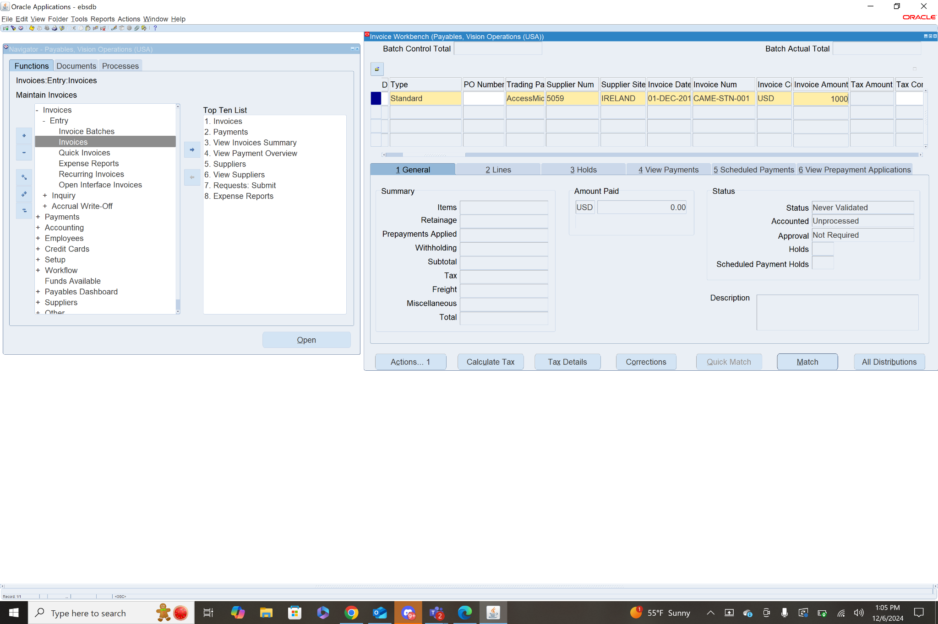

Finally, you will need to create a line item, which is the actual item or items that are being paid for by the invoice. I will just create one item for the amount of $1000. Select a distribution account from the LOV (Accrued Expense), and add a description. Select a Product type (Goods), and select a ship to location if it is not already filled out. Then save.

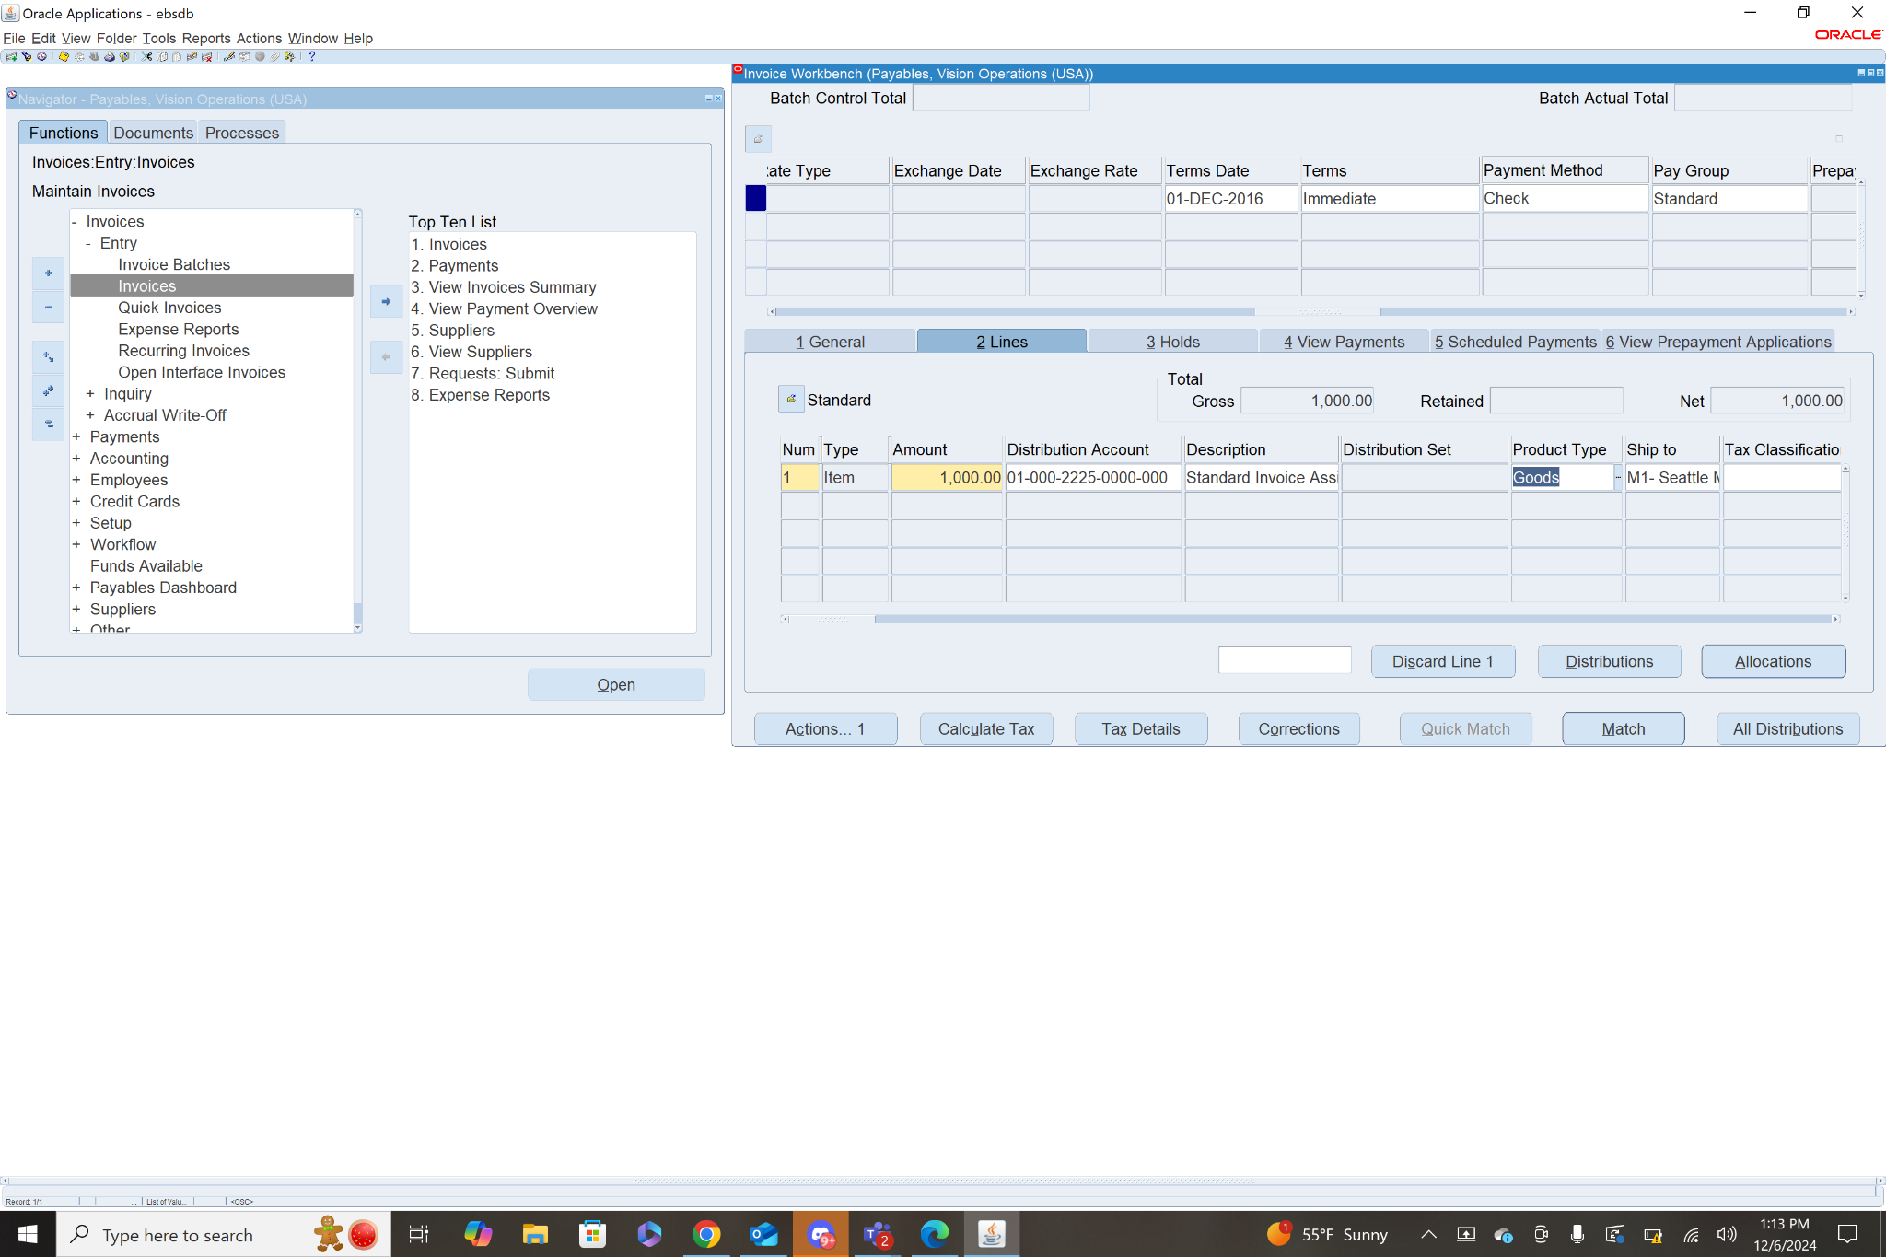

1. **Validate the Invoice:**

* Validate the invoice you just created to ensure there are no errors and it's ready for payment.

To validate an invoice first select the invoice, then in the general tab click actions. This will bring up a list of actions, check the box next to Validate and click ok. This will calculate any taxes that should be added to the invoice. You will need to adjust the header invoice amount to include the taxes, then validate again. For mine no taxes were added, I believe because the supplier site is in Ireland and they don’t have any taxes that pertain to this transaction. This meant mine validated on the first try.

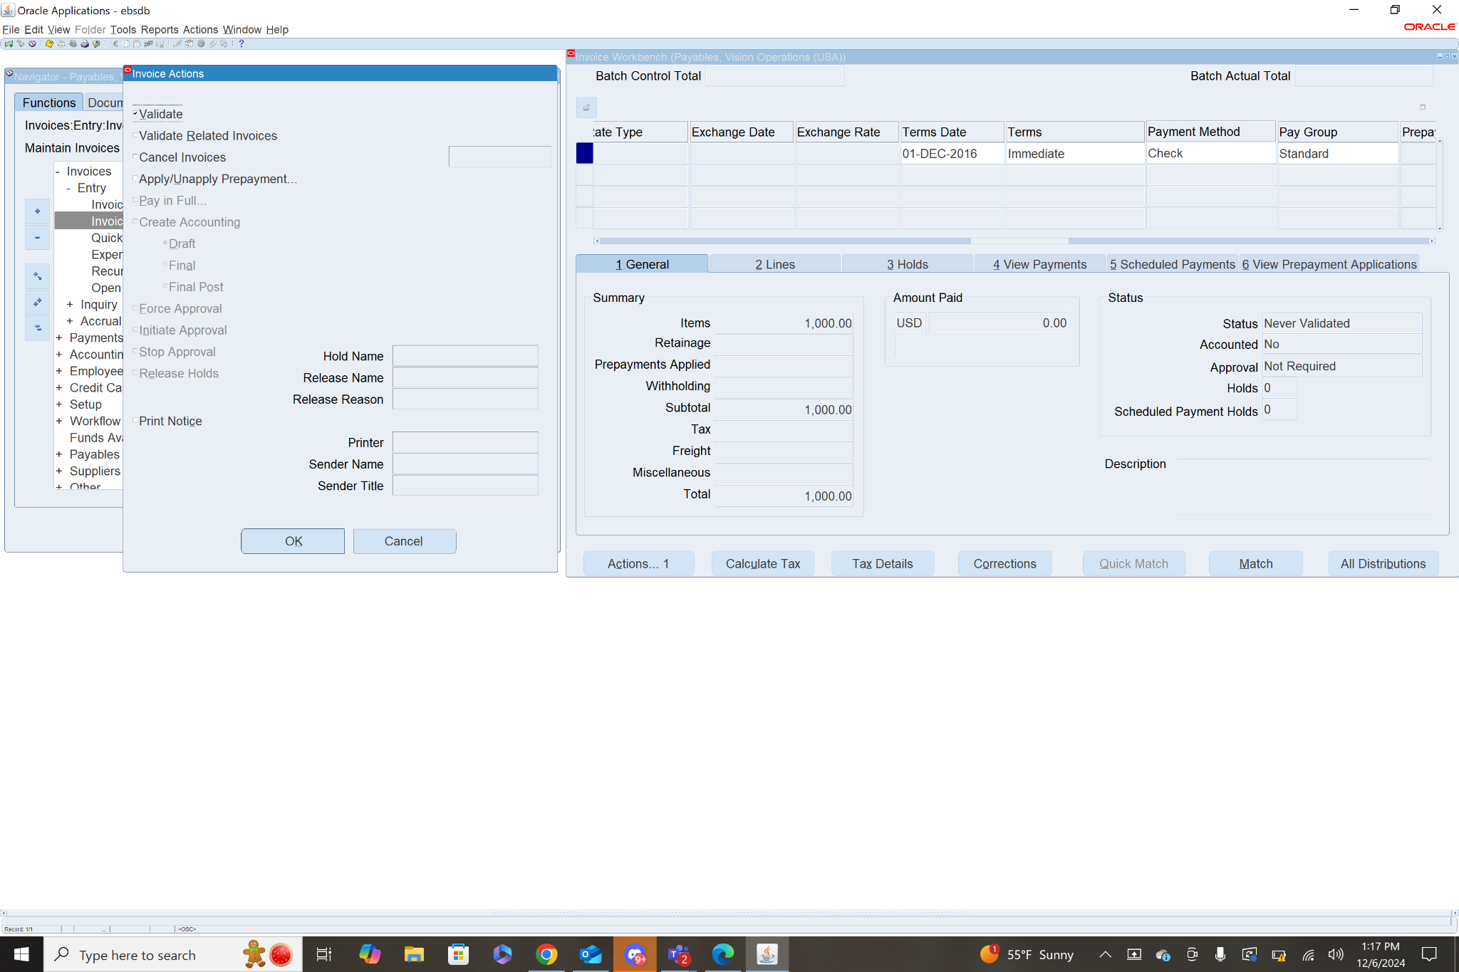

1. **Do Create Accounting & Transfer to General Ledger:**

After the invoice has been validated you need to Create Accounting for the invoice and transfer it to the general ledger. To do this select the validated invoice and in the general tab click Actions. Since the invoice is validated, the Create Accounting is no longer grayed out. Check the box next to Create Accounting, then check Final Post and click OK. It will notify you that accounting has been successful, just click ok.

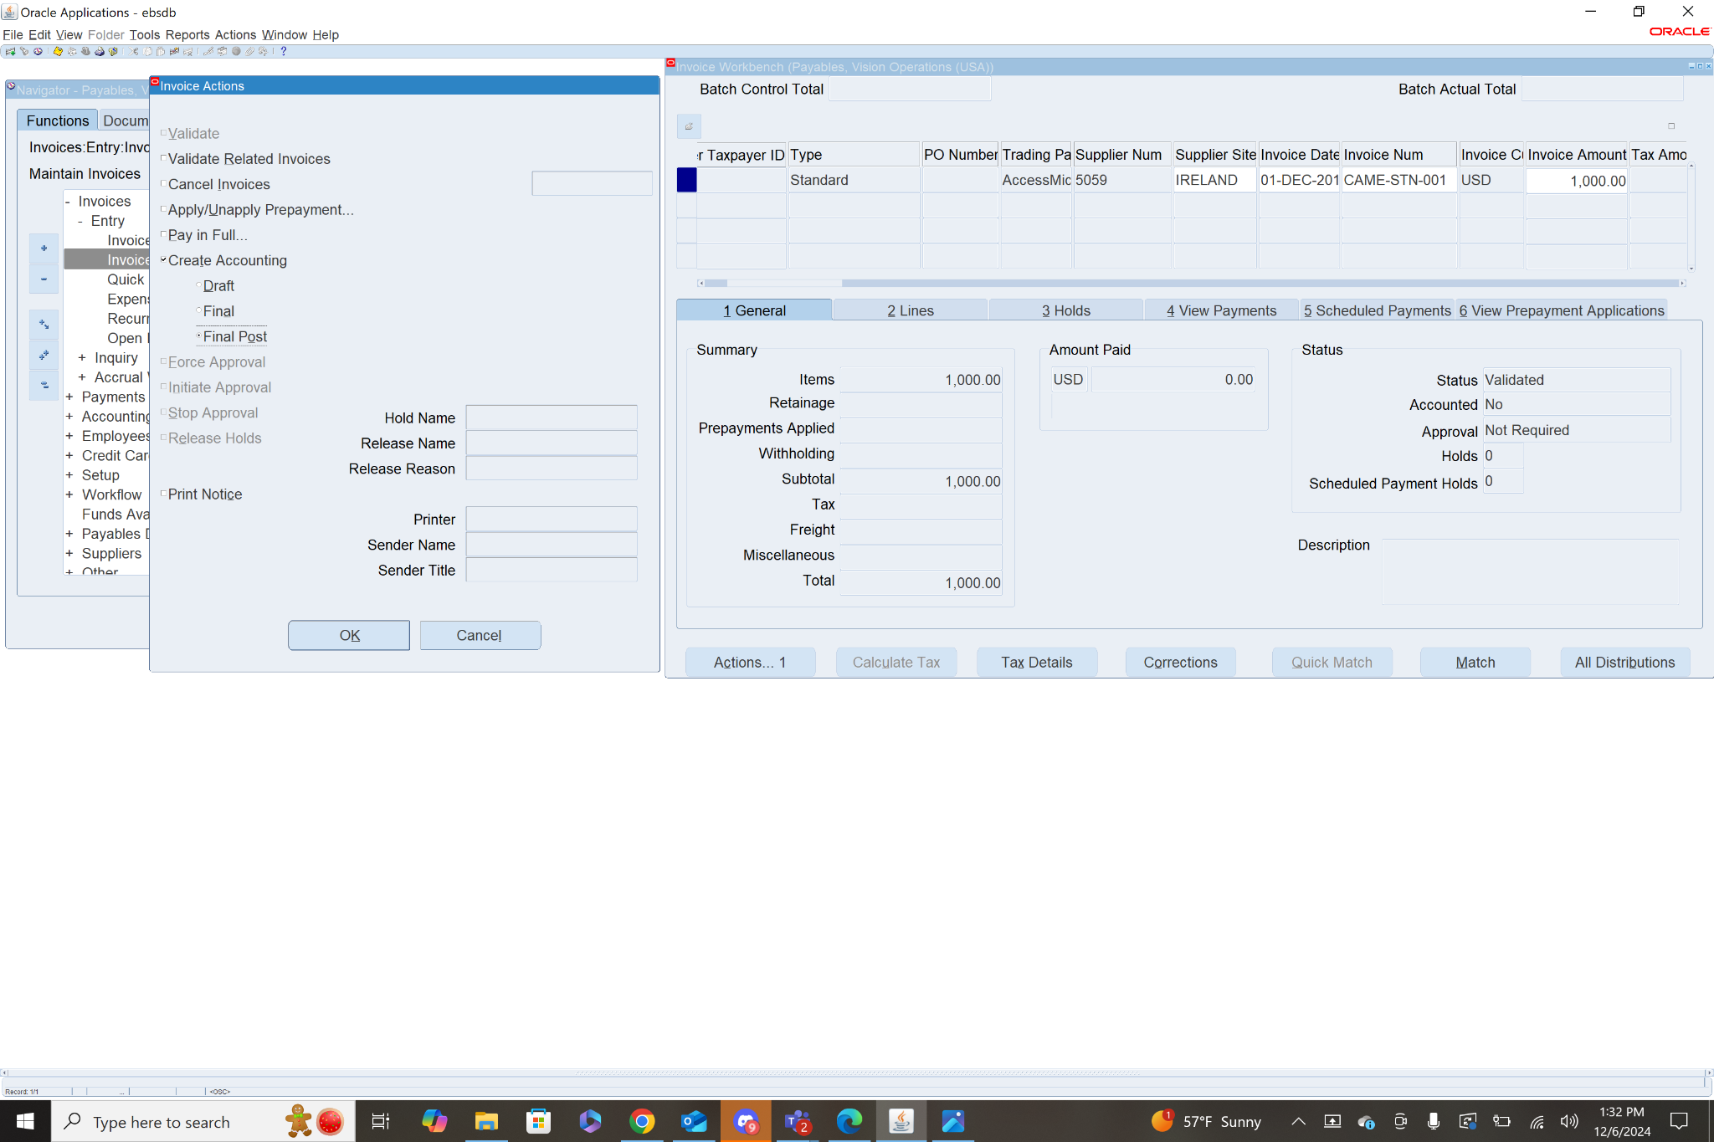

1. **Create A debit Memo** (Validate & Create accounting) .. Explain each & every step with screen shot.

Step 1: Add Header Info - **Navigation: Payables>Invoices>Entry>Invoices**

To create the invoice first select Type (Debit Memo) then fill in the header info: Trading Partner, Supplier Num, Supplier Site, Invoice Date, Invoice Num (CAME-DM-003), Invoice Amount(negative for Debit Memo), GL Date, Payment Currency, Payment Rate Date, Terms Date, Terms(Immediate), Payment Method, then Save.

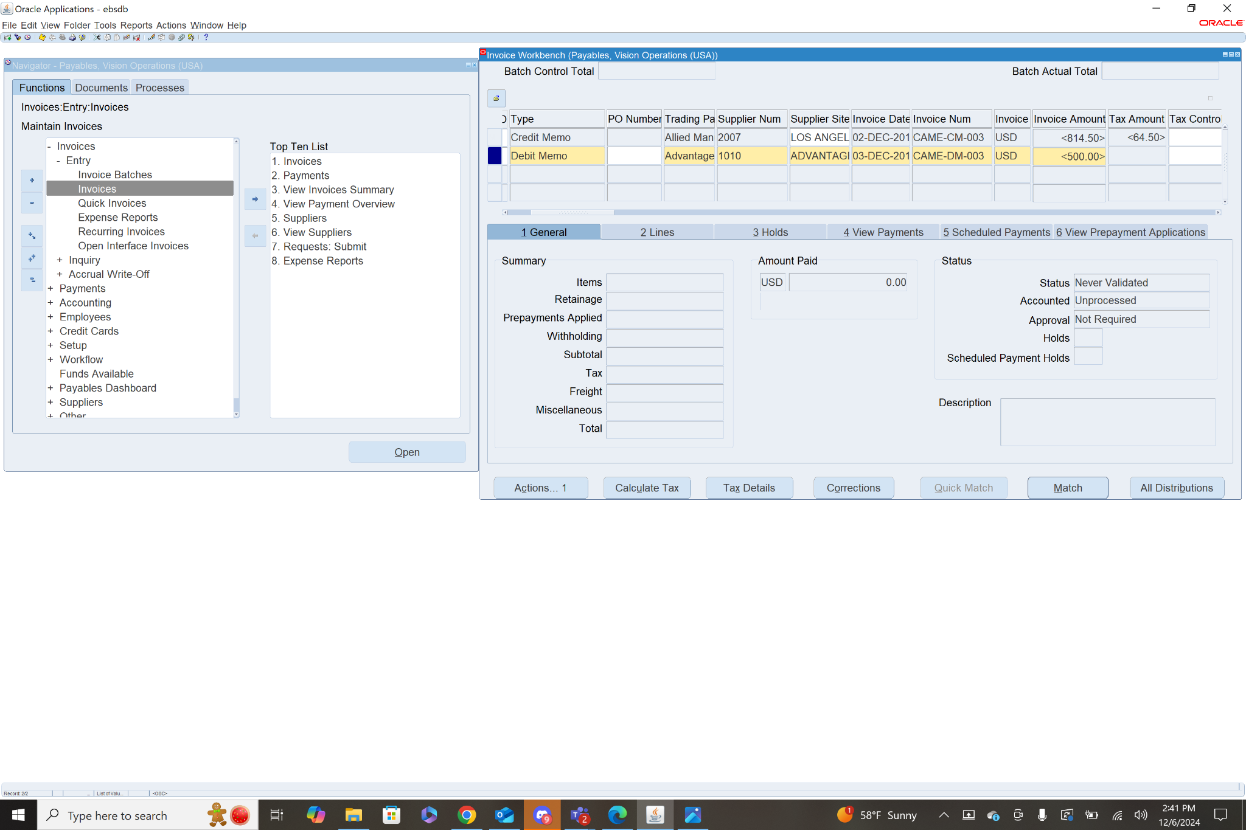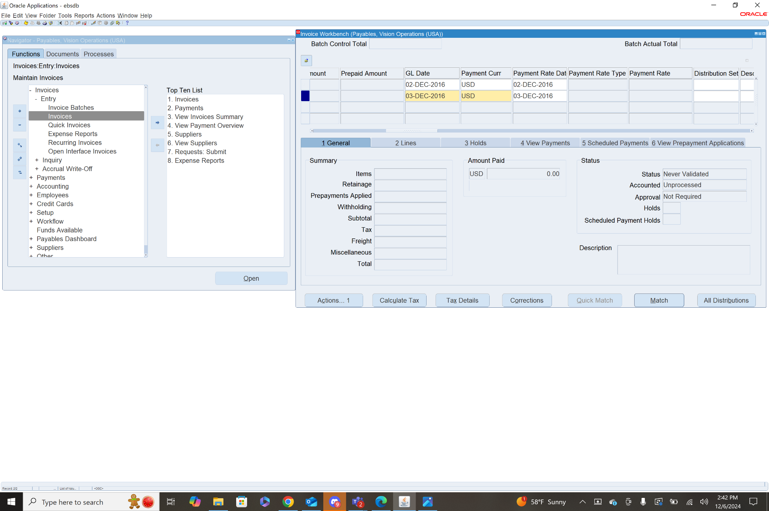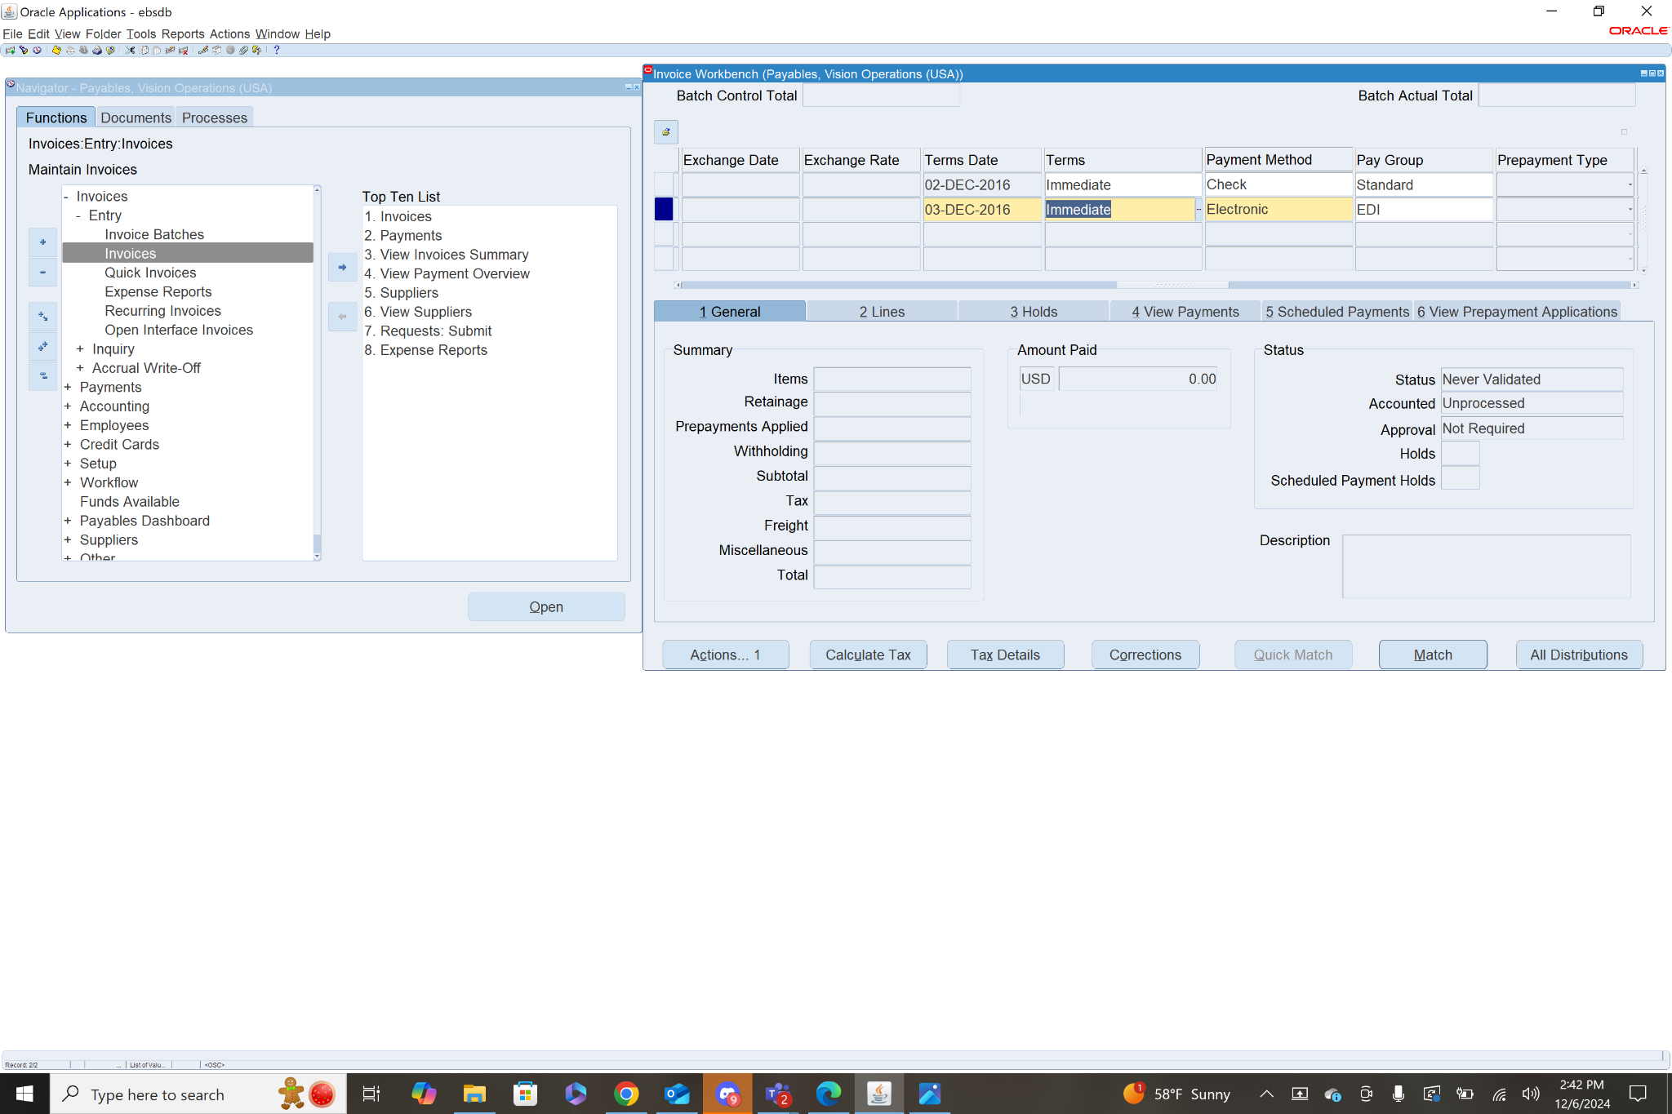

Step 2: Add Line Items

To add a line item, select the Debit memo invoice, then click the Lines tab. Here you will add the Line Item info: Amount (the total amount of line items should match invoice amount), Distribution Account, Description, Product Type, Ship to location, then Save.

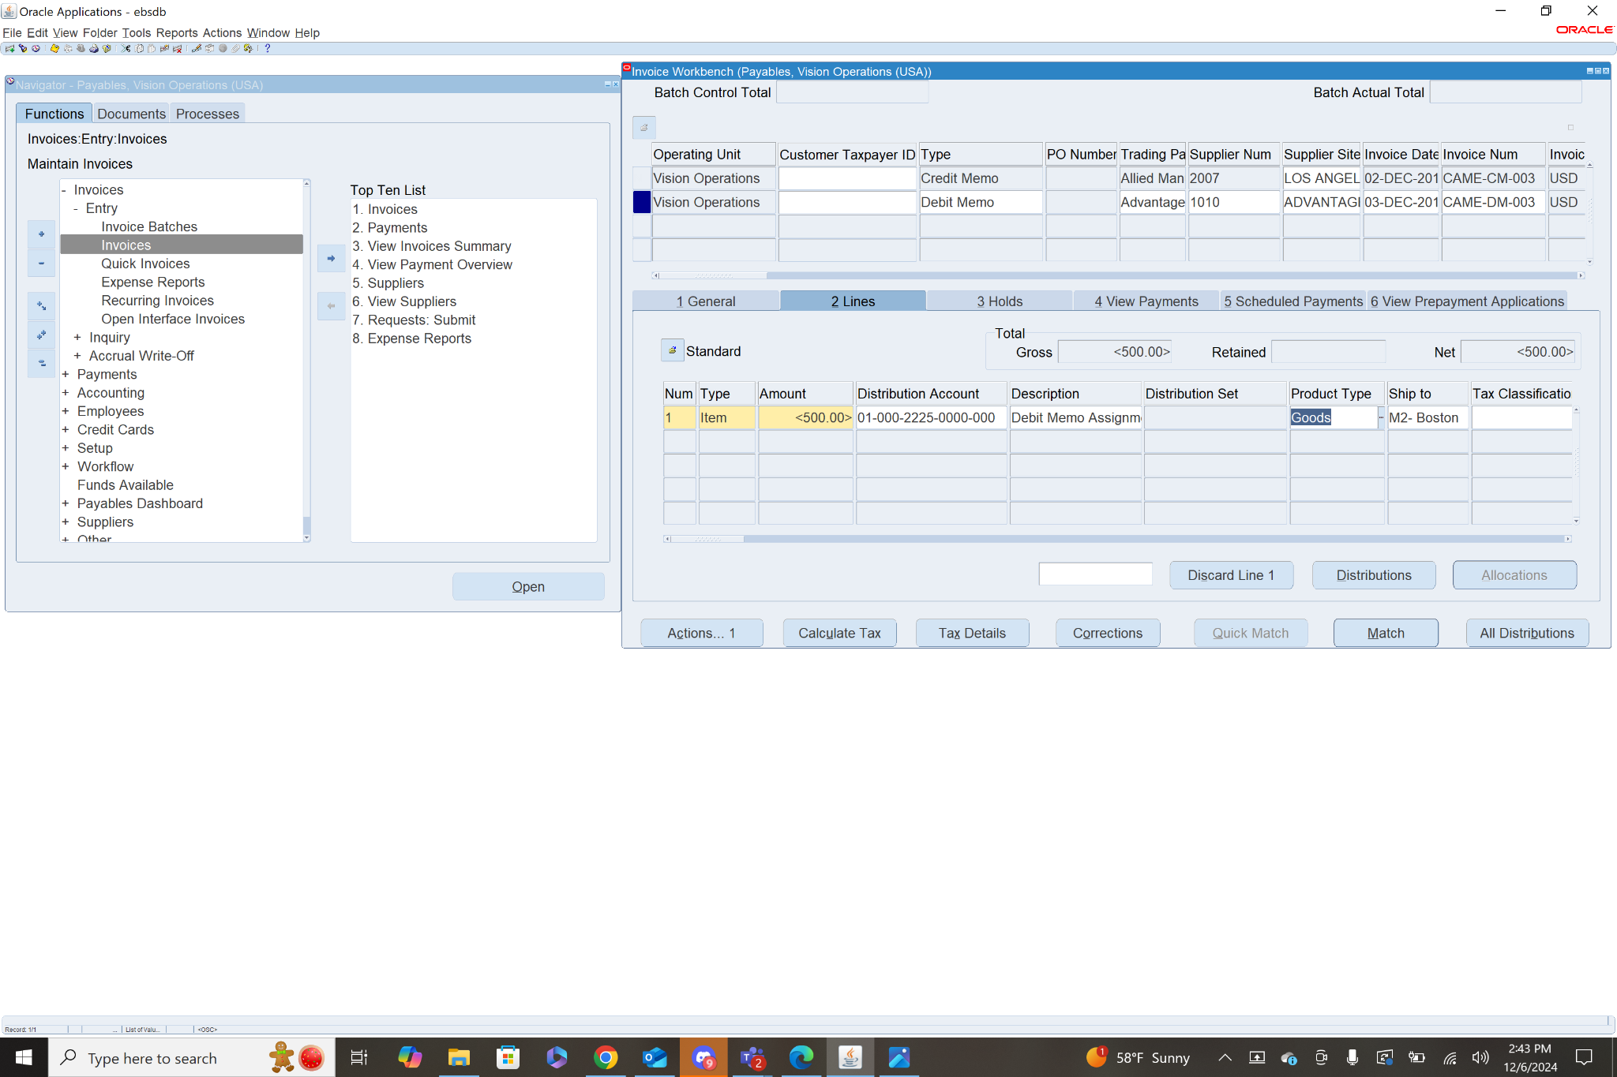

Step 3: Validate the Invoice

To validate select the invoice, then in the general tab click actions. From this menu check the box next to Validate and click OK. This will calculate the taxes associated with the invoice. In order to officially validate the invoice you must adjust the Invoice amount to include the taxes.

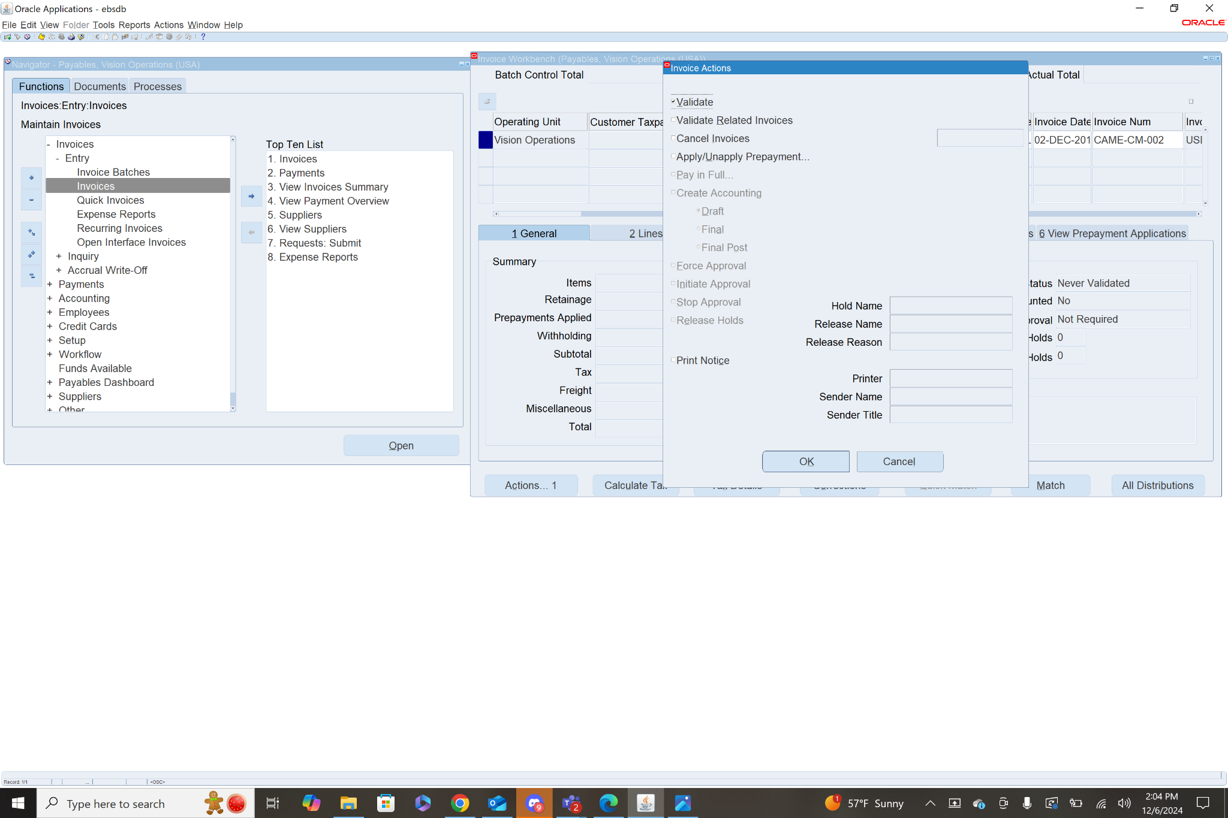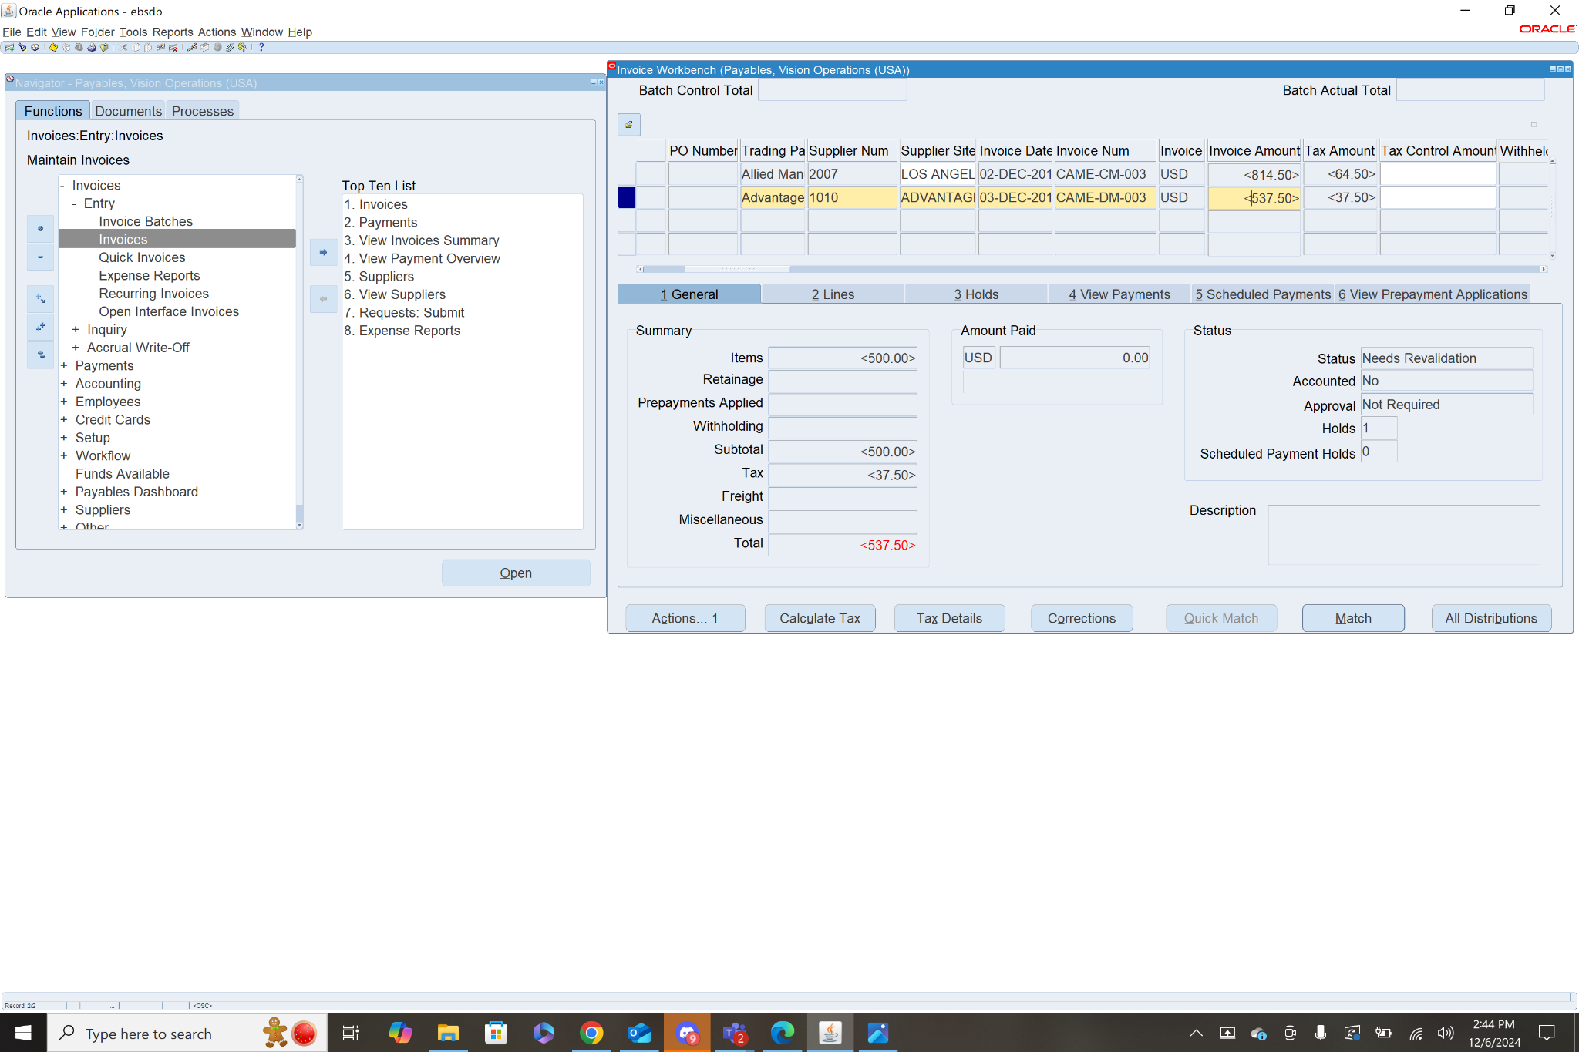

After adjusting the invoice amount to the correct amount, Save and then validate again.

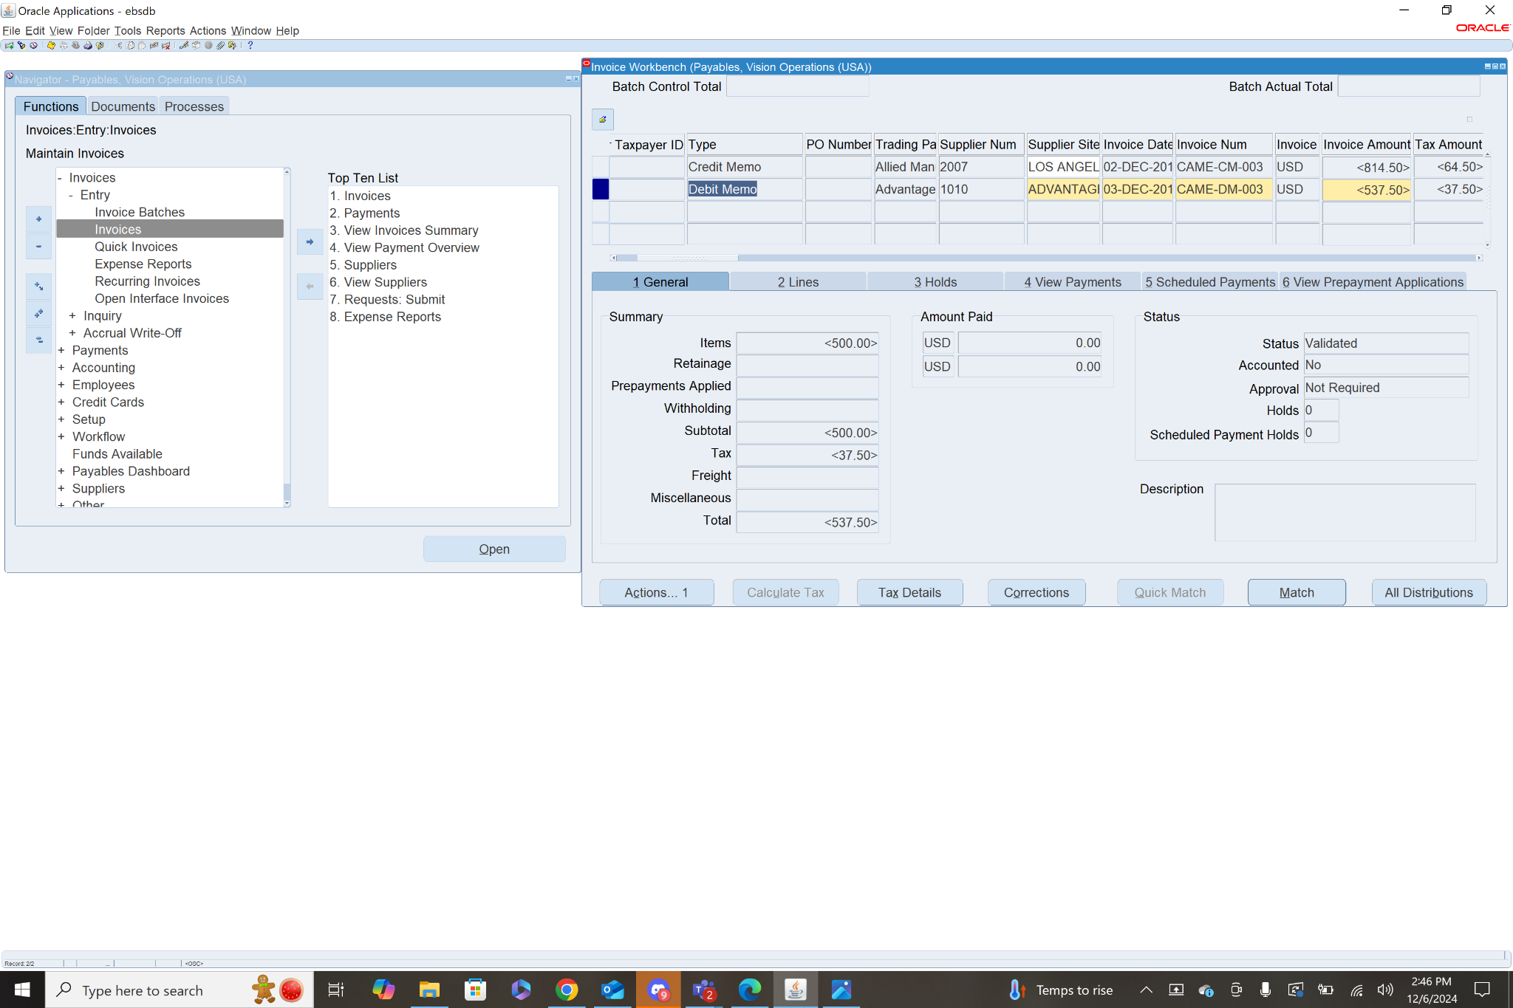

Step 4: Create Accounting

After the Invoice has been validated (the status shows as validated), you are able to create accounting for the invoice. To do this select the invoice, in the general tab click actions. From the menu check the box next to Create Accounting then check Final Post. This will create an accounting record of the invoice and transfer it to the general ledger. Once these steps are all completed the invoice should show Status: Validated and Accounted: Yes

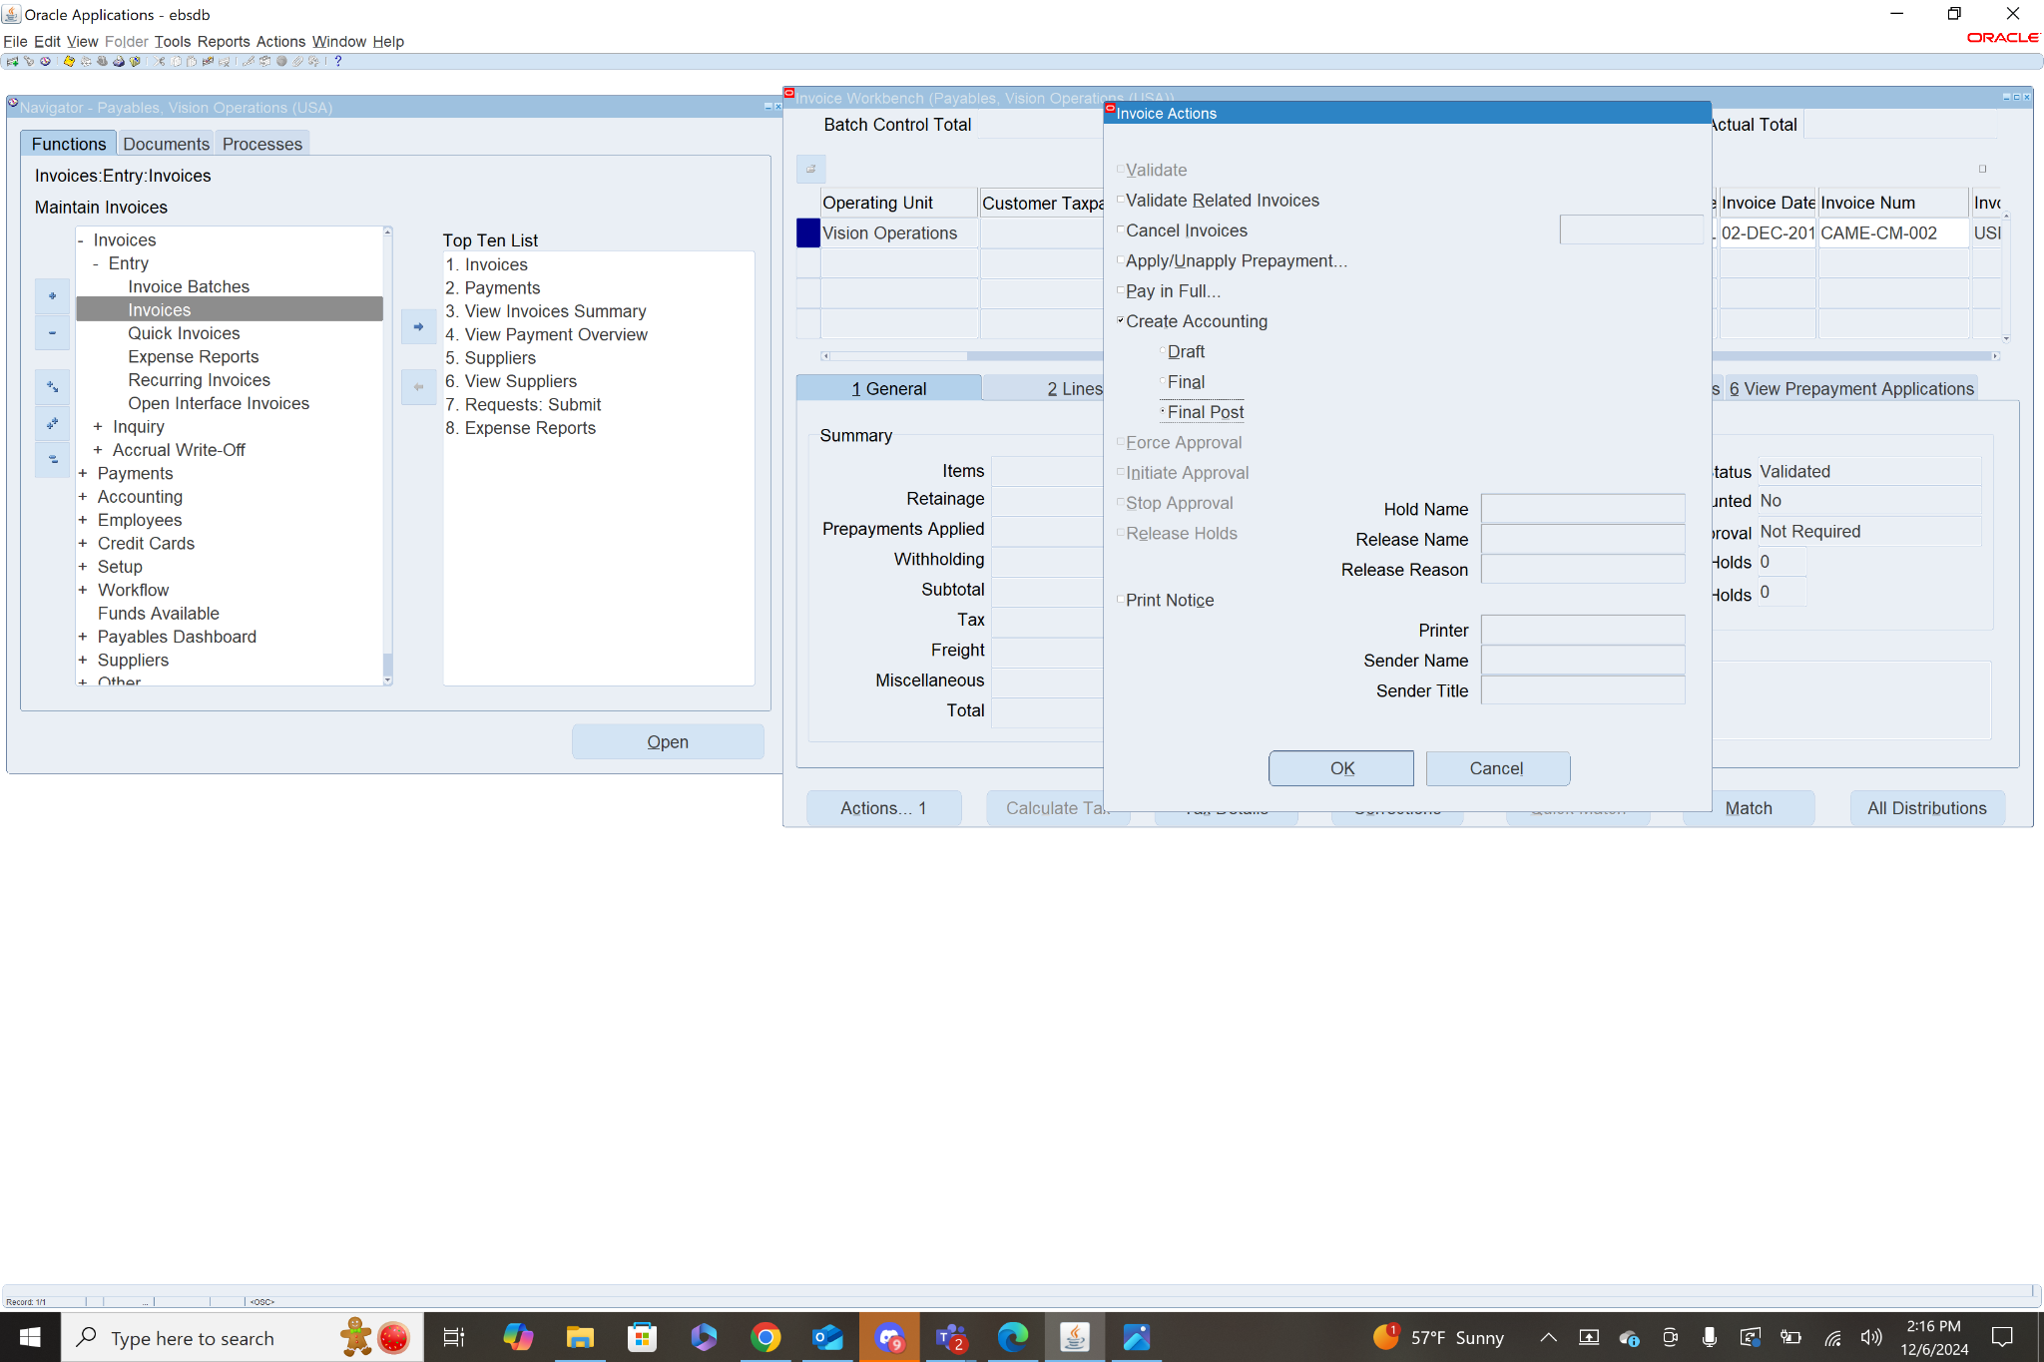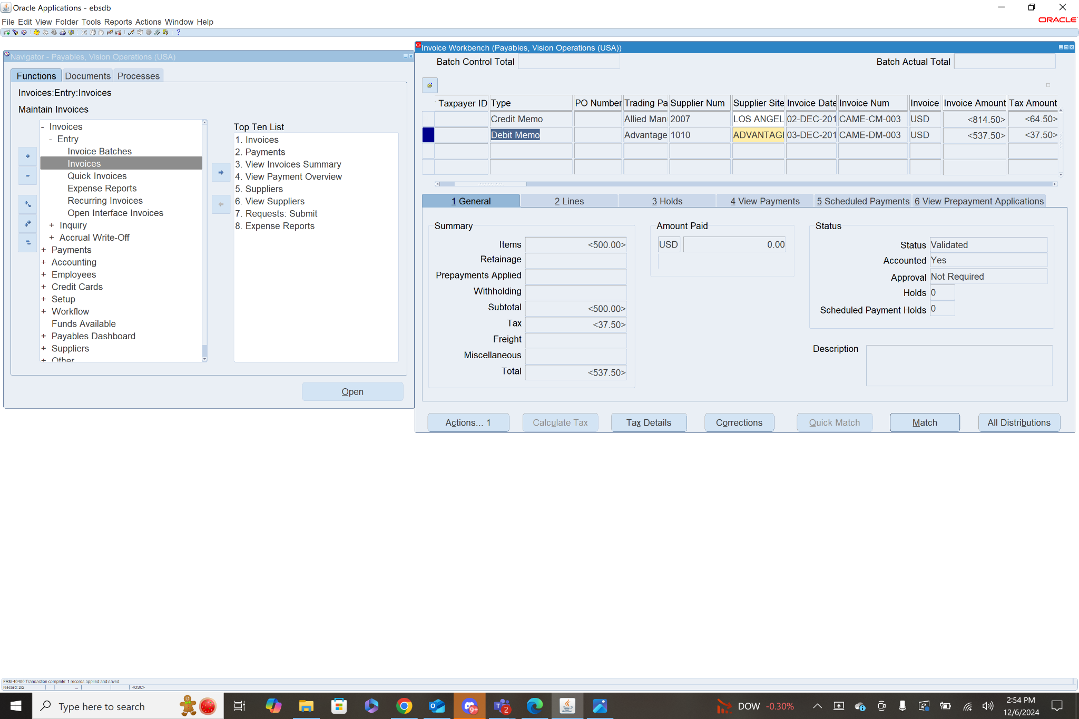

1. **Create a Credit Memo** (Validate & Create accounting) .. Explain each & every step with screen shot.

Step 1: Add Header Info - **Navigation: Payables>Invoices>Entry>Invoices**

To create the invoice first select Type (Credit Memo) then fill in the header info: Trading Partner, Supplier Num, Supplier Site, Invoice Date, Invoice Num (CAME-CM-003), Invoice Amount(negative for Credit Memo), GL Date, Payment Currency, Payment Rate Date, Terms Date, Terms(Immediate), Payment Method, then Save.

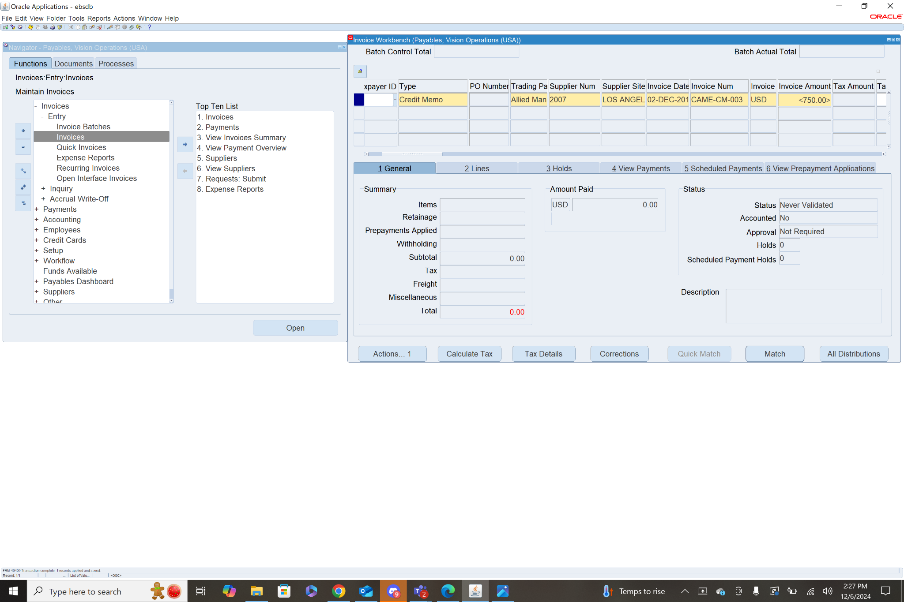

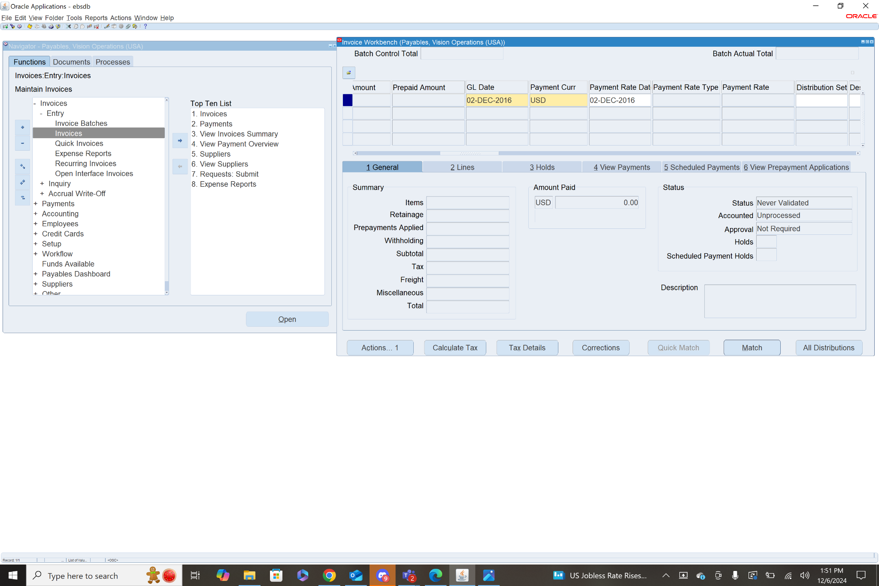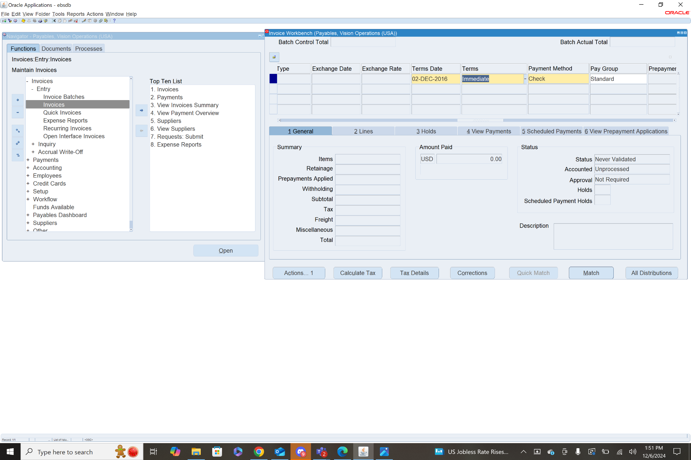

Step 2: Add Line Items

To add a line item, select the Credit memo invoice, then click the Lines tab. Here you will add the Line Item info: Amount (the total amount of line items should match invoice amount), Distribution Account, Description, Product Type, Ship to location, then Save.

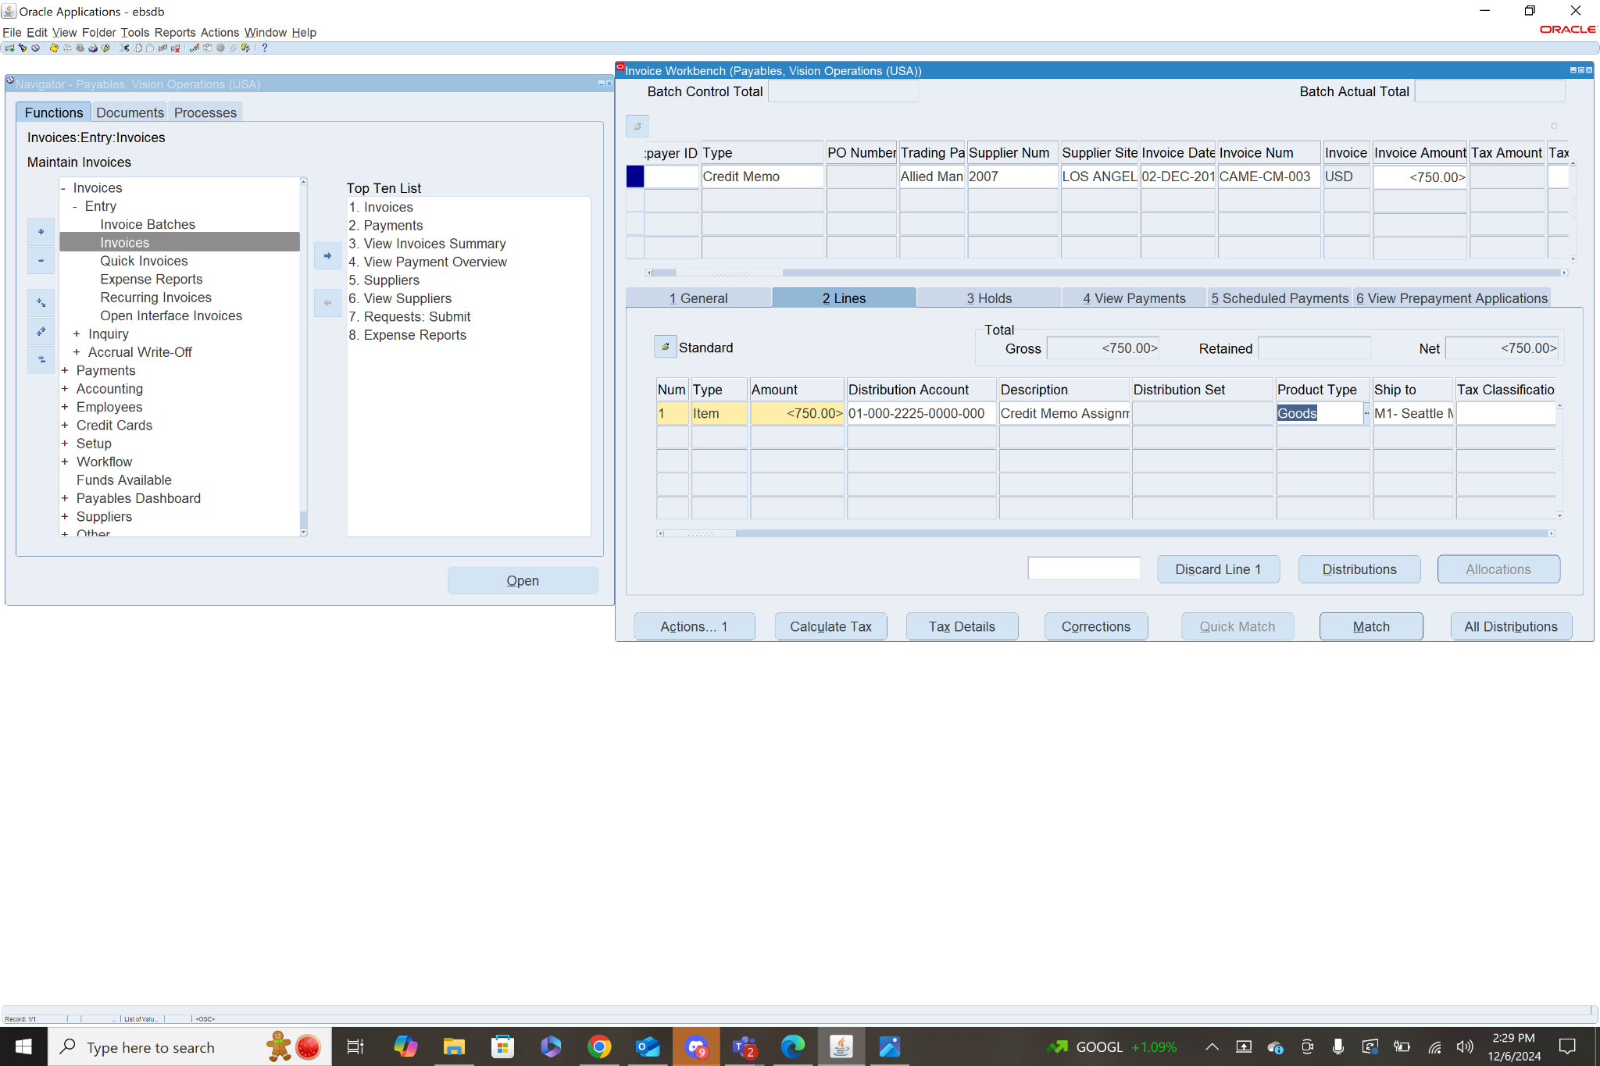

Step 3: Validate the Invoice

To validate select the invoice, then in the general tab click actions. From this menu check the box next to Validate and click OK.This will calculate the taxes associated with the invoice. In order to officially validate the invoice you must adjust the Invoice amount to include the taxes.

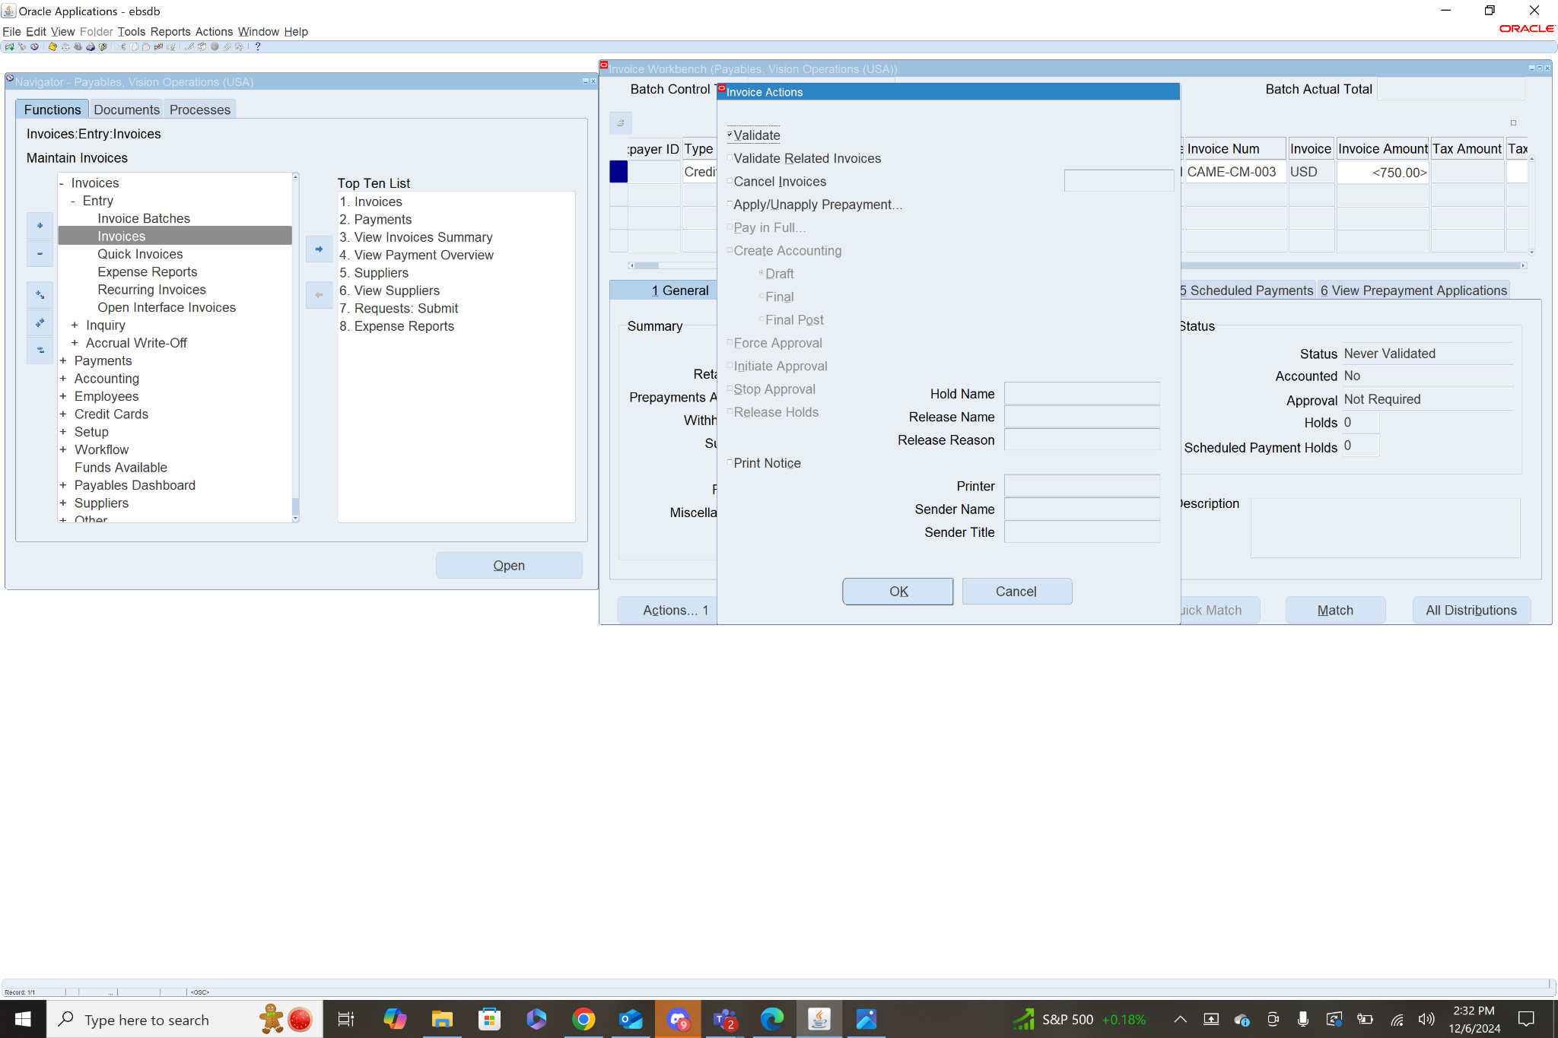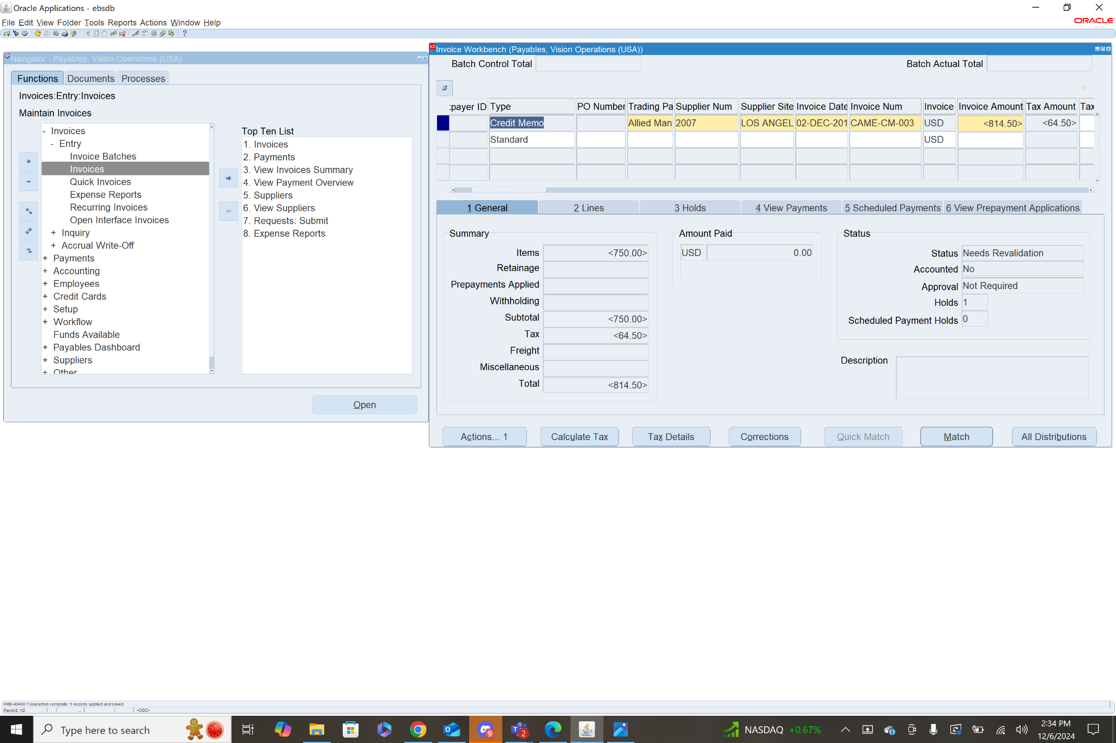

After adjusting the invoice amount to the correct amount, Save and then validate again.

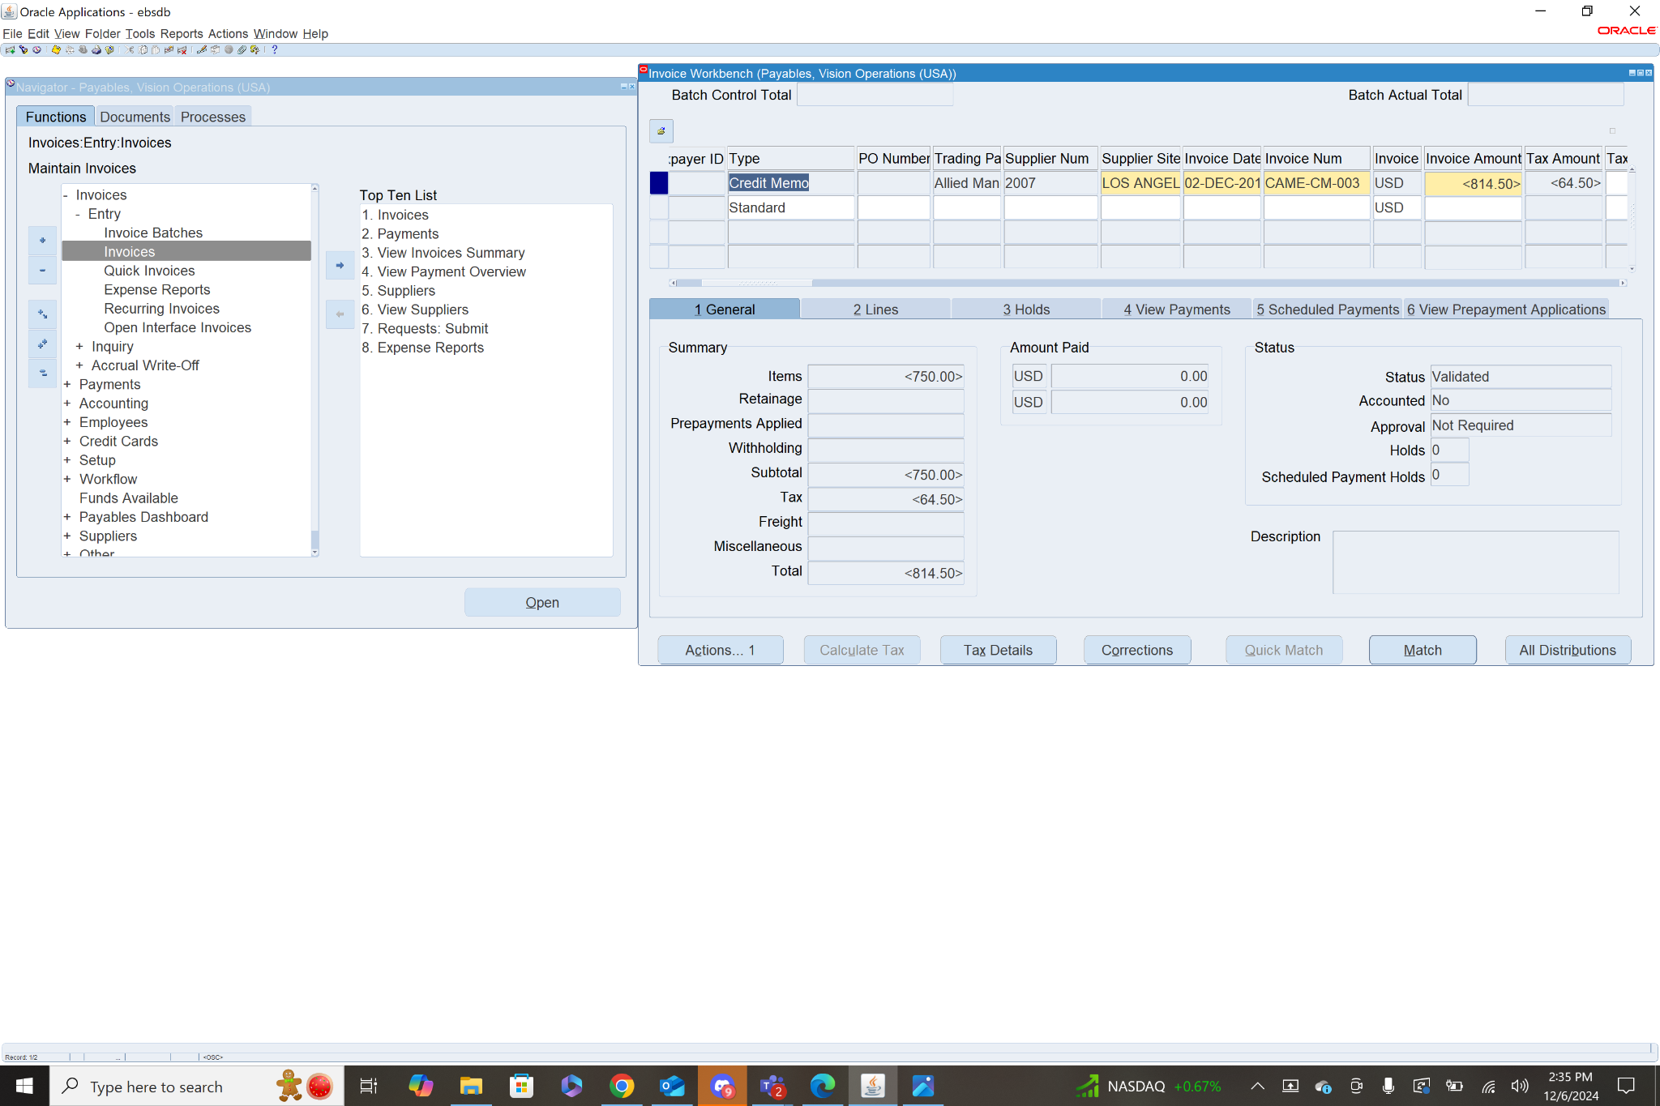

Step 4: Create Accounting

After the Invoice has been validated, and the status shows validated. You are able to create accounting for the invoice. To do this select the invoice, in the general tab click actions. From the menu check the box next to Create Accounting then check Final Post. This will create an accounting record of the invoice and transfer it to the general ledger. Once these steps are all completed the invoice should show Status: Validated and Accounted: Yes

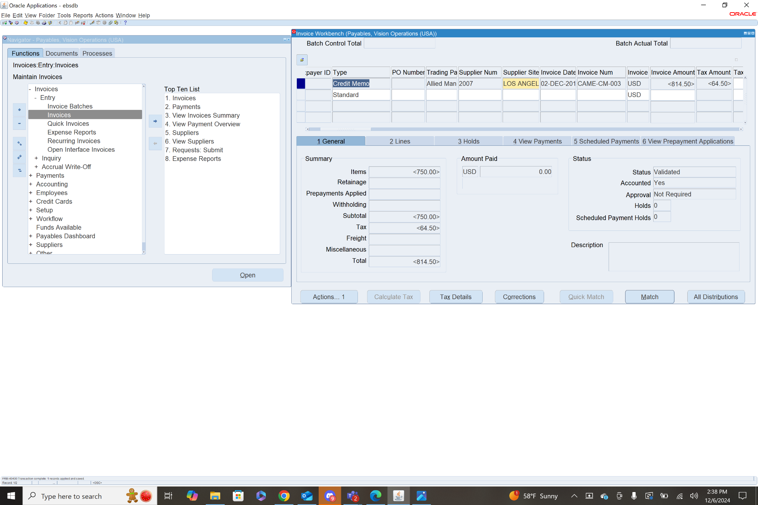

1. **Query a PO based Invoice & check the Po match details.**

To query a PO based invoice first you must navigate to the invoice workbench. **Payables>Invoices>Entry>Invoices.** From here to query an invoice press fn+f11, then in the PO Number field you can type in a specific PO Number or % to grab all in PO invoices. To run the query press ctrl+fn+f11.

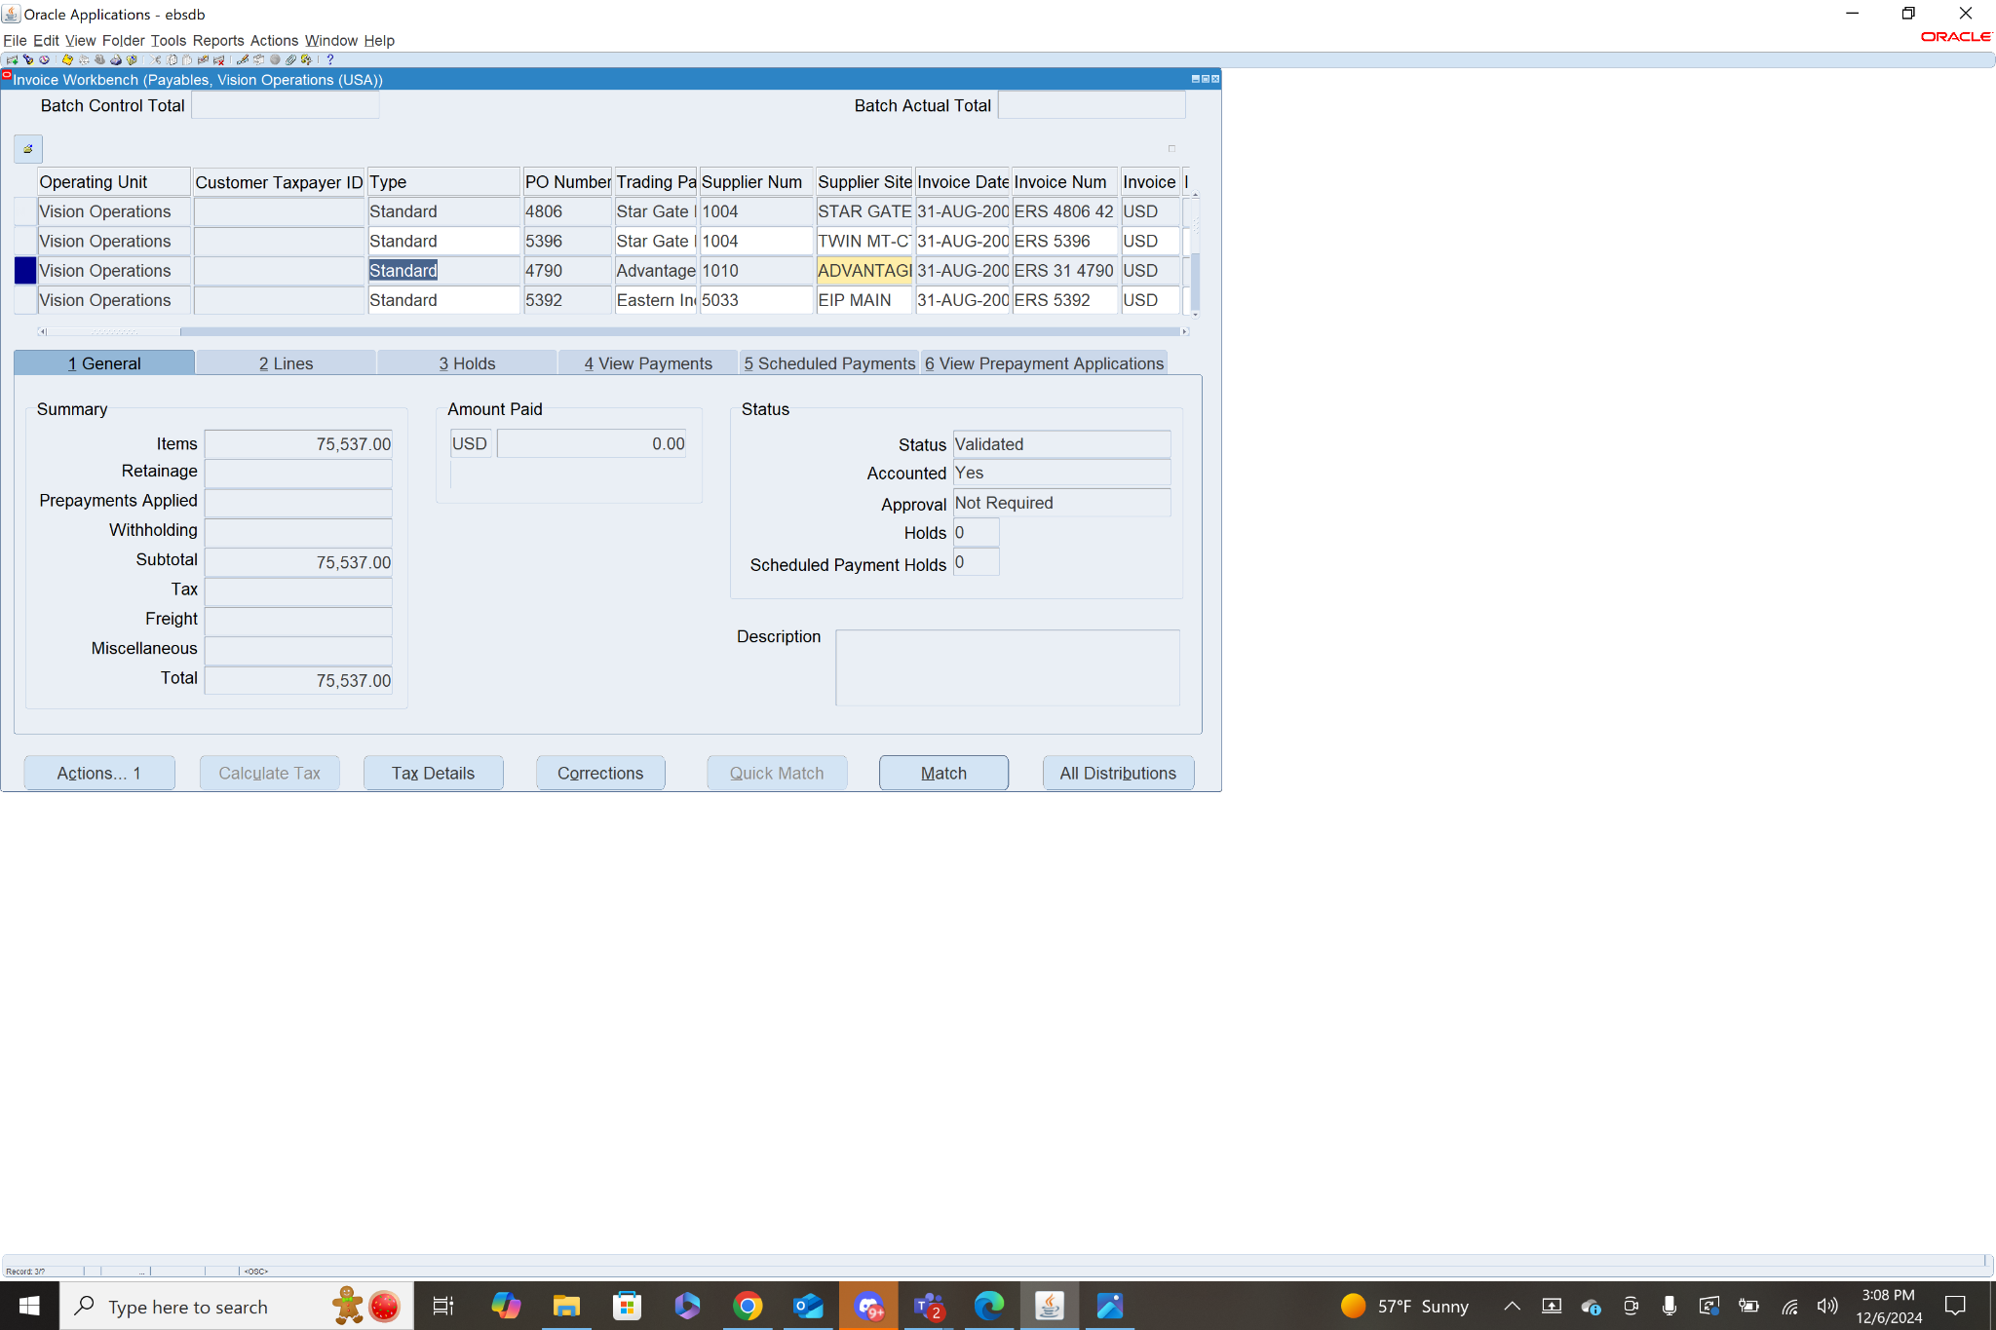

I queried with % to get all PO invoices, I selected the invoice for PO Number 4790. With this invoice selected, in the general tab i clicked match. From this menu you can find the purchase orders for matching, based on the given Purchase Order Number 4790. Click Find.

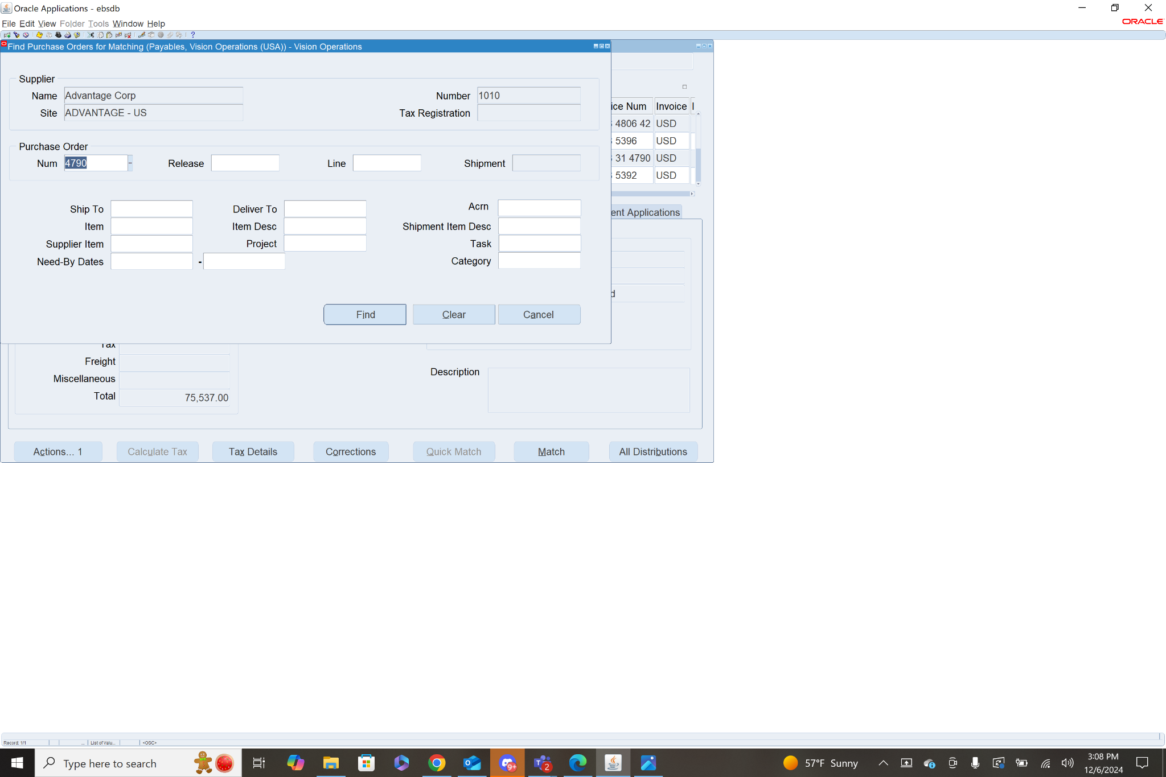

This will take you to a menu that shows all of the items associated with the invoice that match the PO Number 4790. It includes information like unit price, match amount, and match basis.

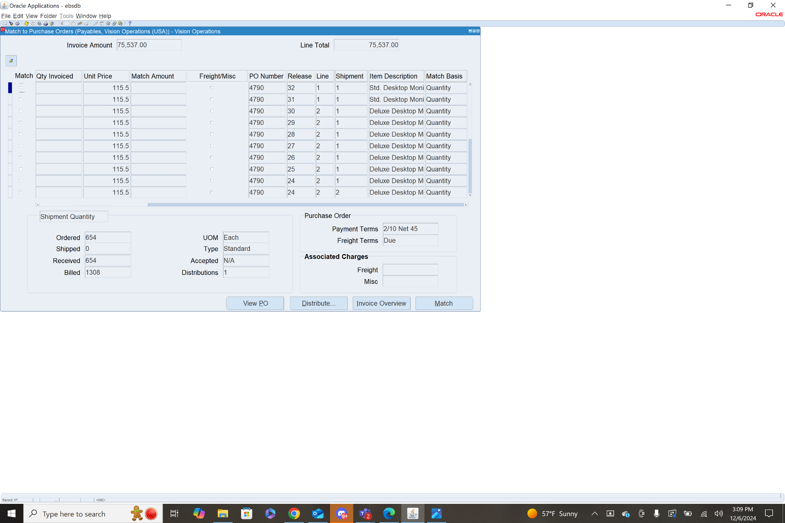

1. **Create a PRE-Payment Invoice [Temporary].**

Step 1: Add Header Info - **Navigation: Payables>Invoices>Entry>Invoices**

To create the prepayment invoice first select Type (Prepayment) then fill in the header info: Trading Partner, Supplier Num, Supplier Site, Invoice Date, Invoice Num (CAME-PRE-001), Invoice Amount, GL Date, Payment Currency, Payment Rate Date, Terms Date, Terms(Immediate), Payment Method, Prepayment Type(Temporary), Settlement Date, then Save.

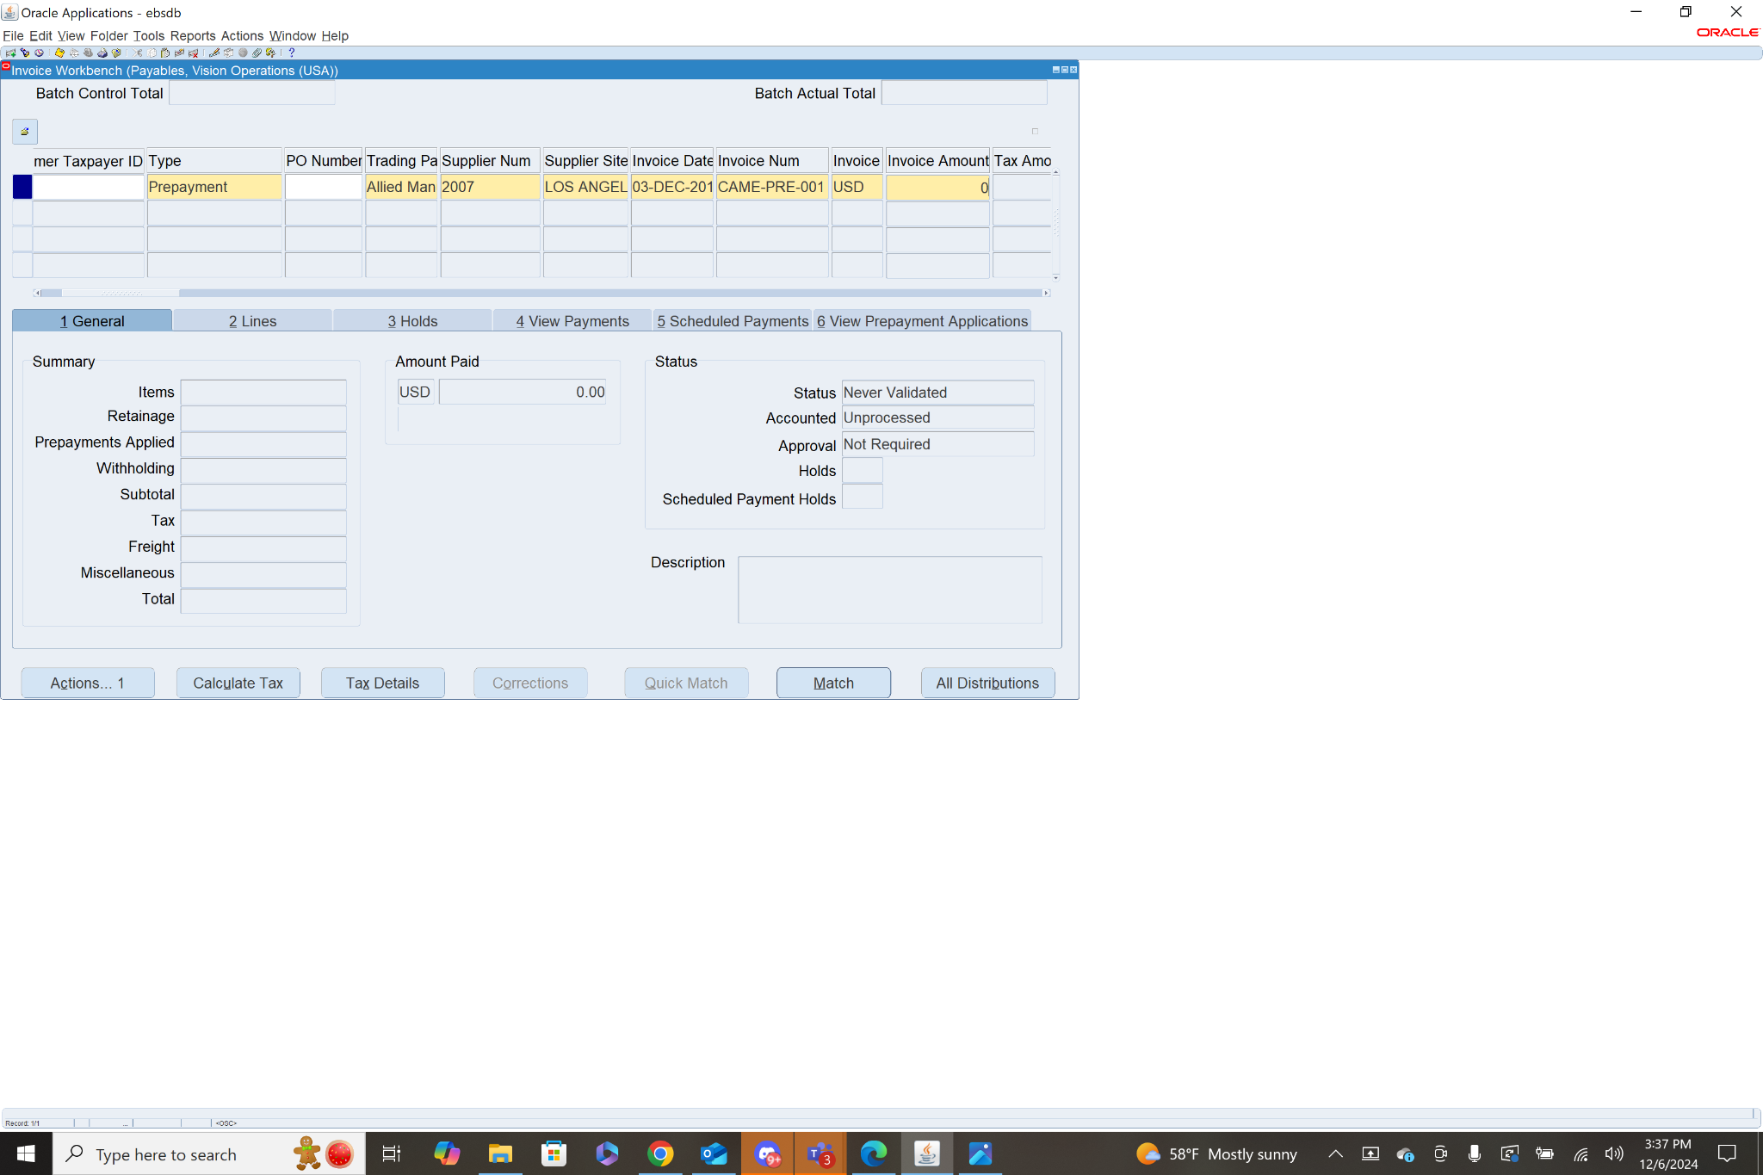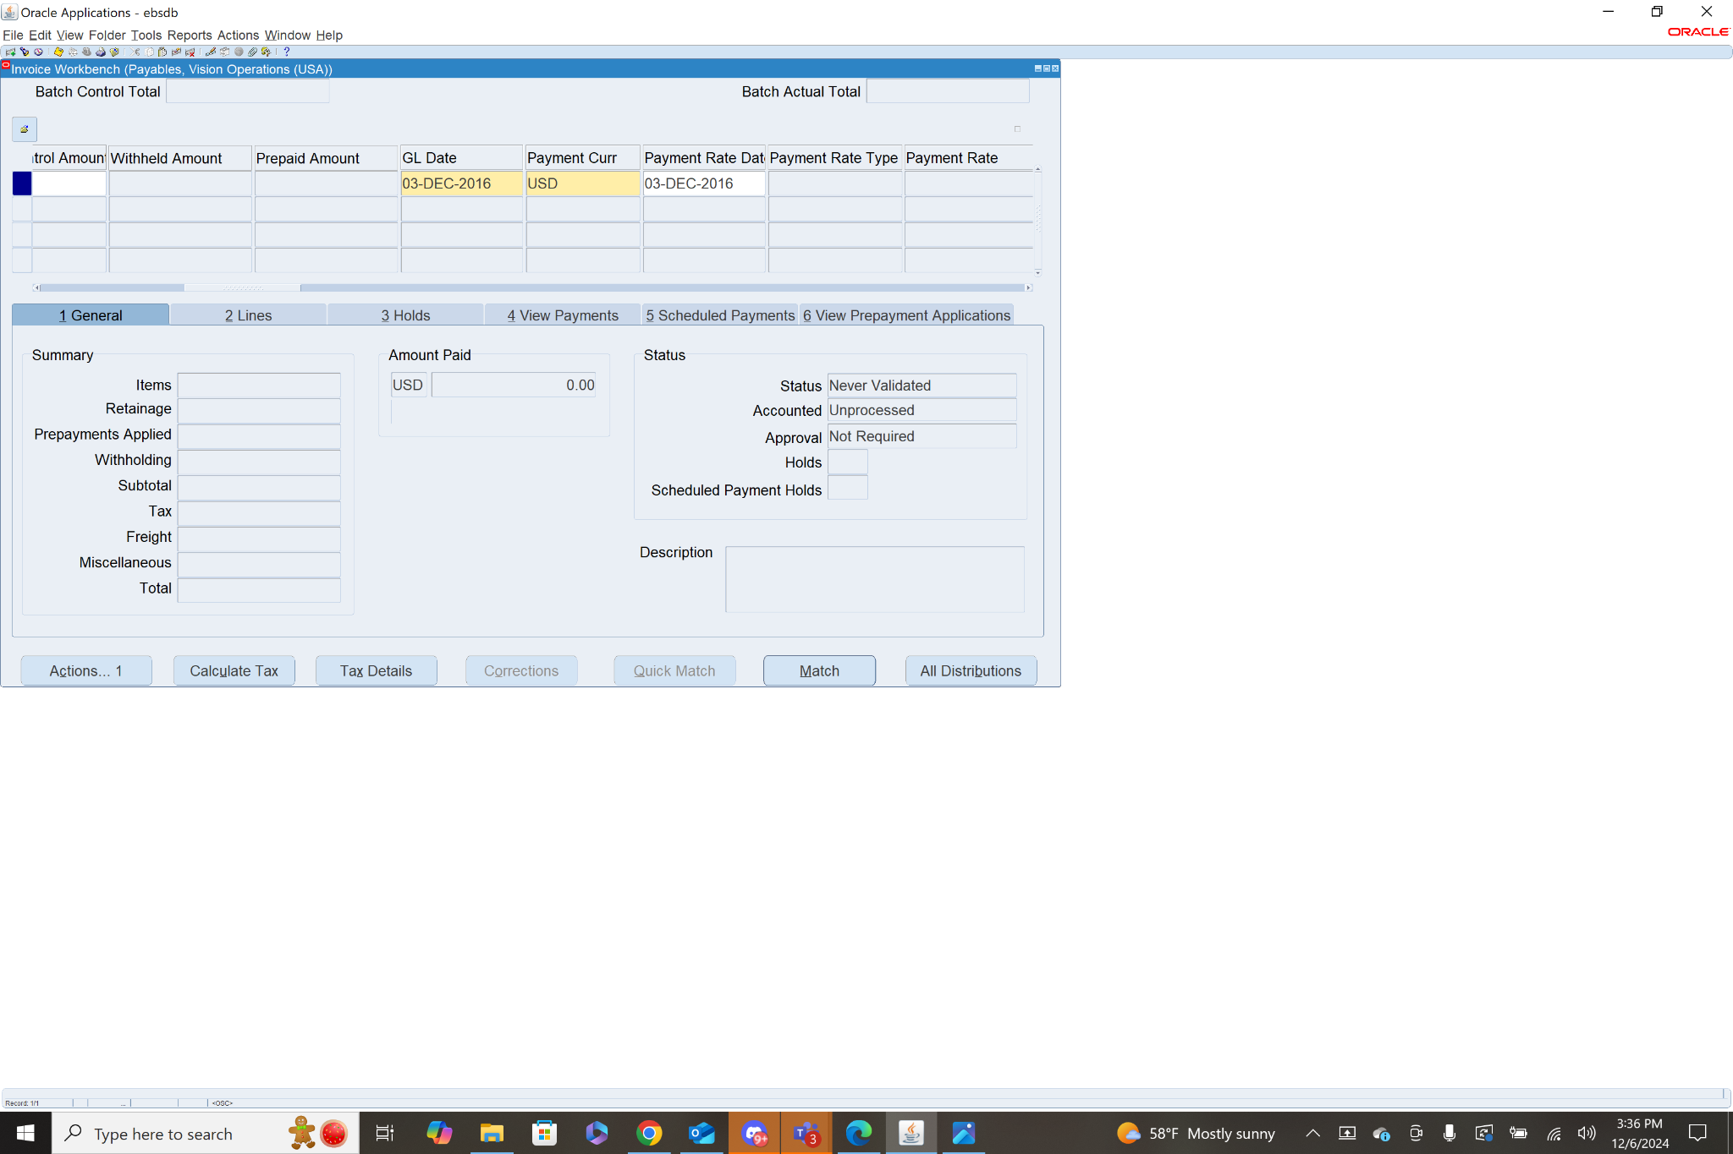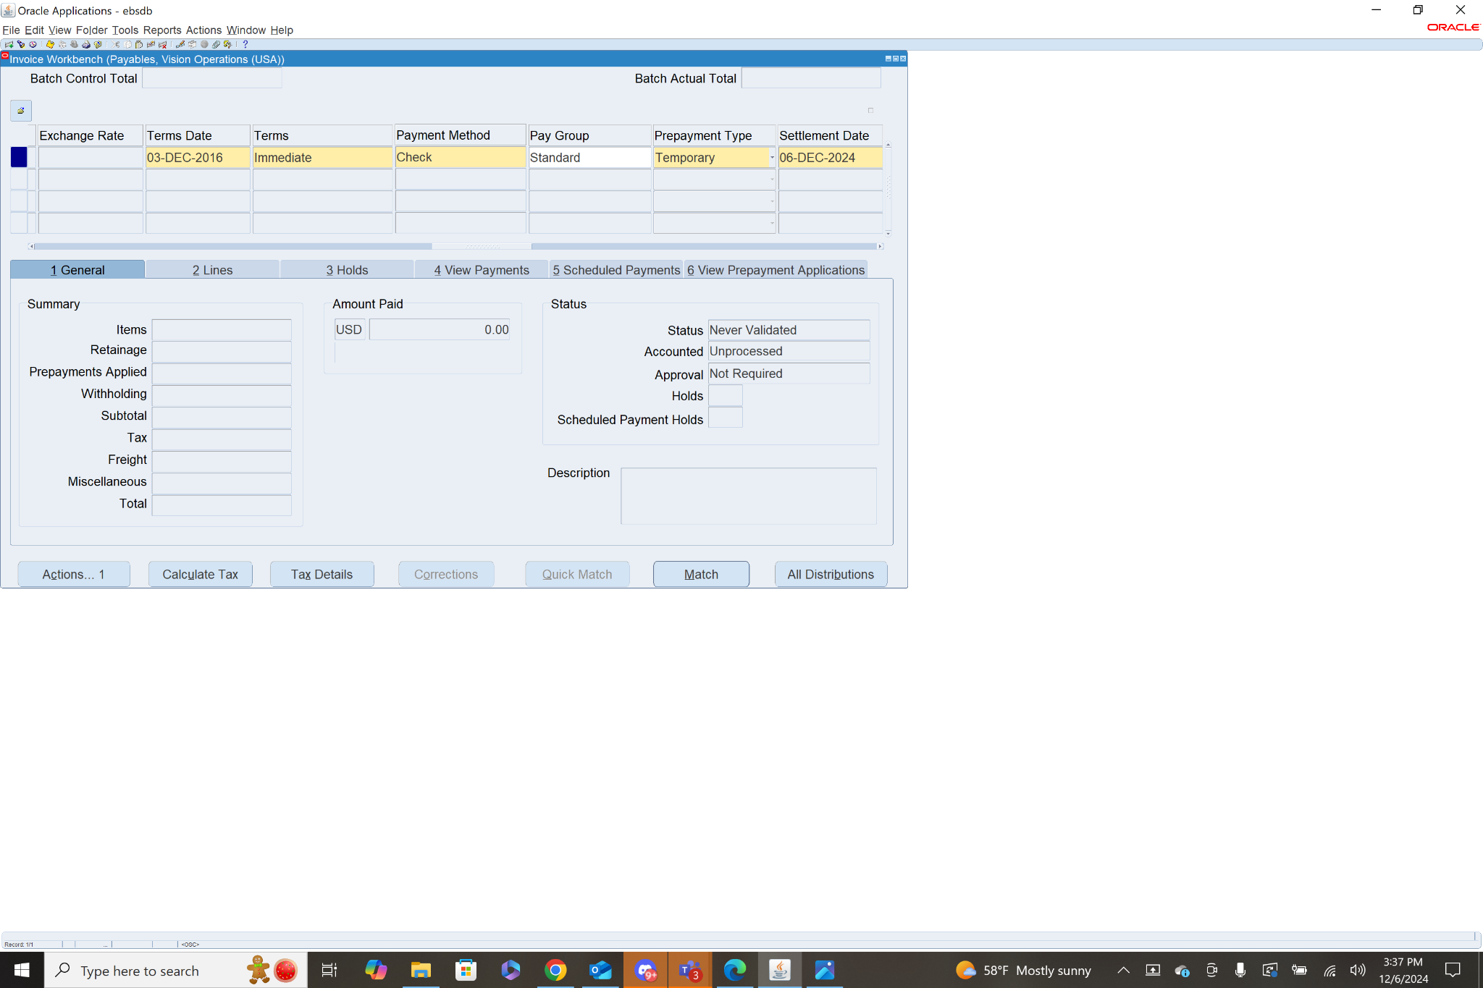

Step 2: Add Line Items

To add a line item, select the prepayment invoice, then click the Lines tab. Here you will add the Line Item info: Amount (the total amount of line items should match invoice amount), Distribution Account, Description, Ship to location, then Save.

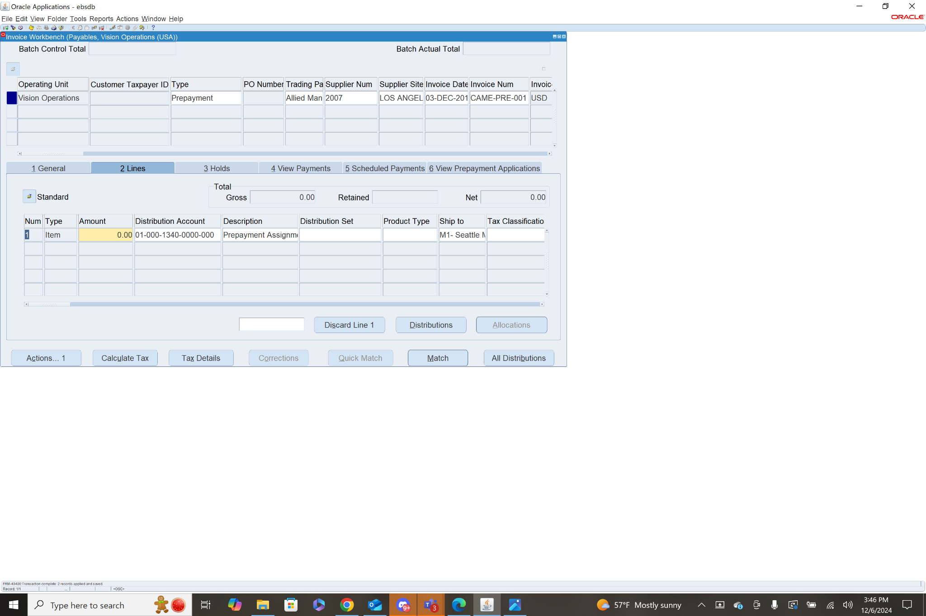

Step 3: Validate the Invoice

To validate select the invoice, then in the general tab click actions. From this menu check the box next to Validate and click OK.This will calculate the taxes associated with the invoice, if any are applicable. If there is a need for tax corrections, you will need to adjust the header invoice amount to include taxes.

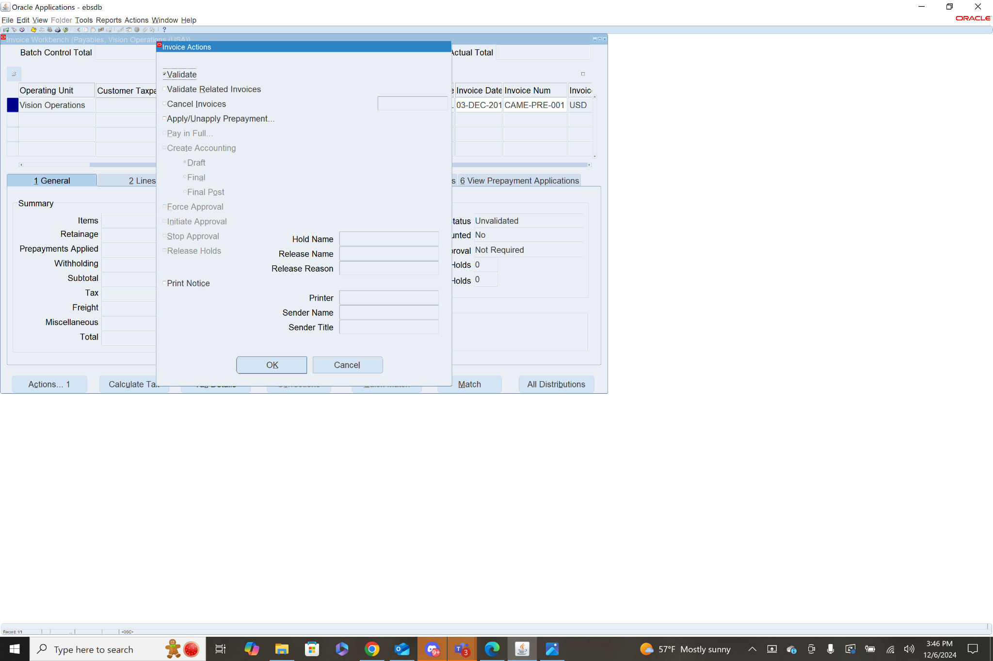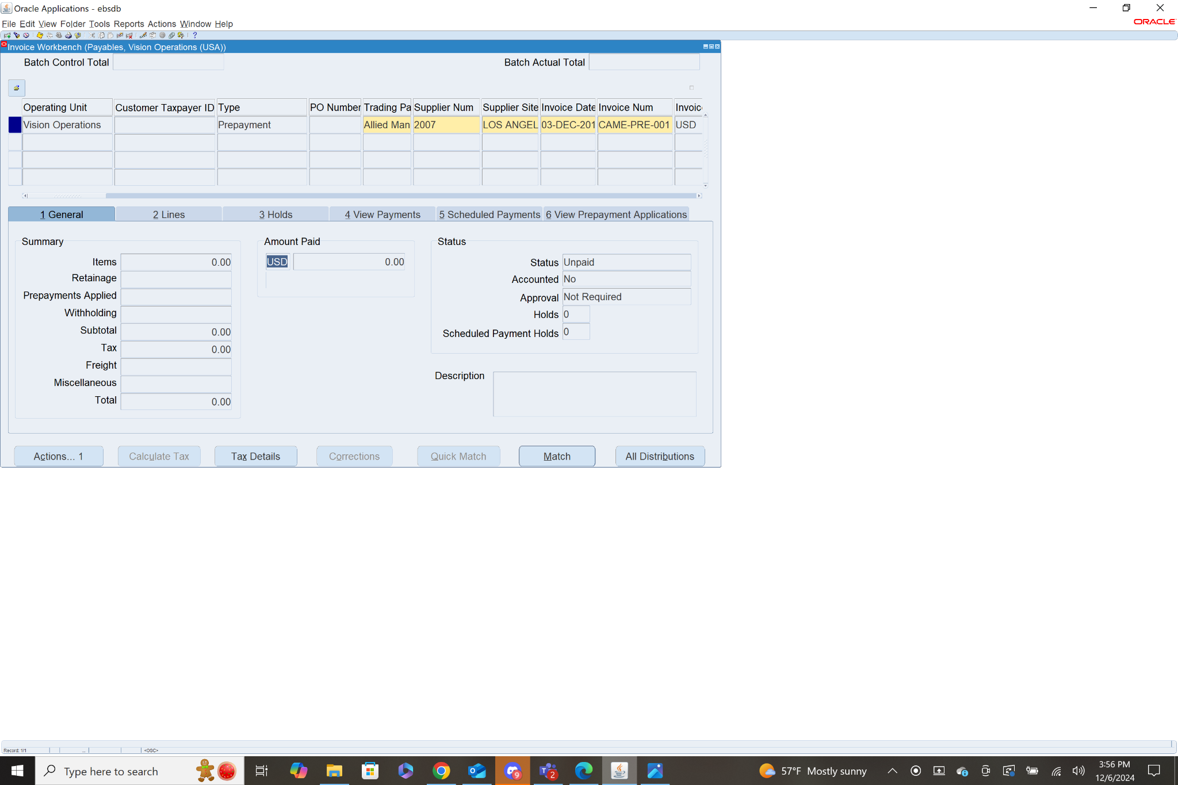

1. **Make single Payment for Standard Invoice**

* Navigate to the **Payments** window.
* Create a payment for the invoice

To make a payment for a specific invoice first navigate to the invoice workbench: **Payables>Invoices>Entry>Invoices.** When in the invoice workbench use fn+f11 to query a specific invoice. I will enter “CAME-STN%”, then press ctrl+fn+f11 to query the standard invoice I made earlier. With the invoice selected go to the general tab and click actions. From this menu check the box next to pay in full and click OK.

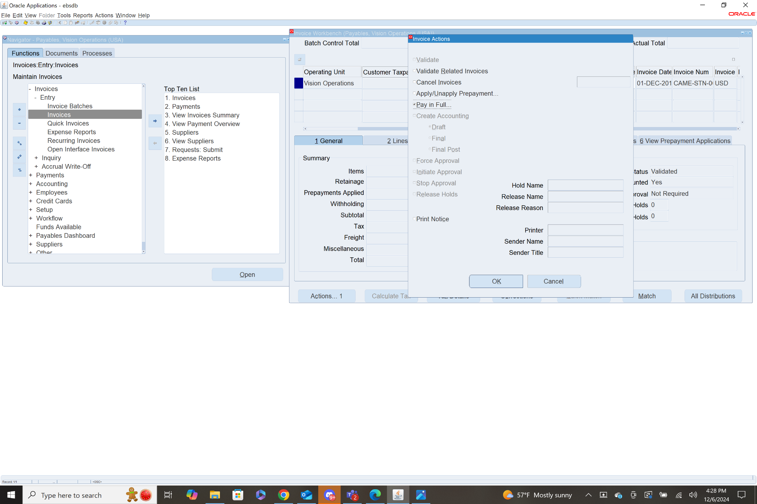

This will bring you to the payment workbench menu. Fill in the fields payment date, and payment process profile. Bank account and payment method, are required but will be auto filled. Payment document, and document number are also required, but they will auto fill after entering the payment process profile.

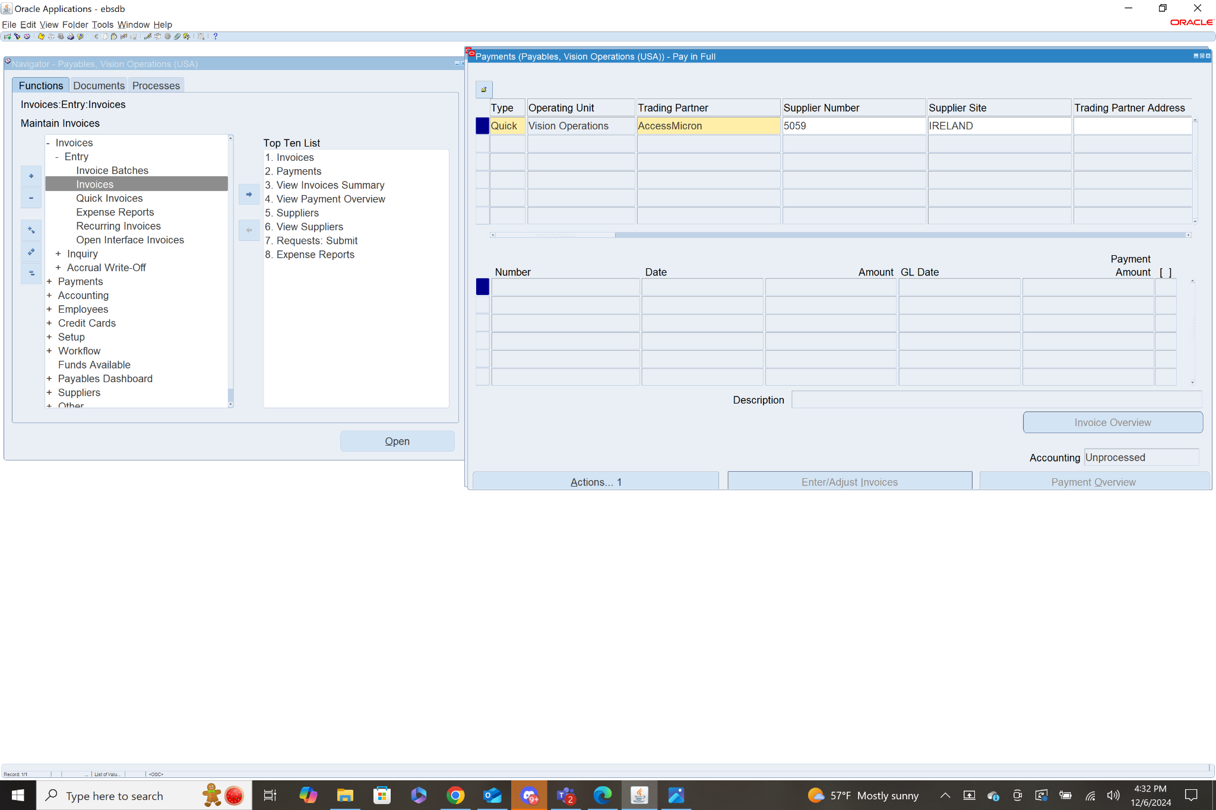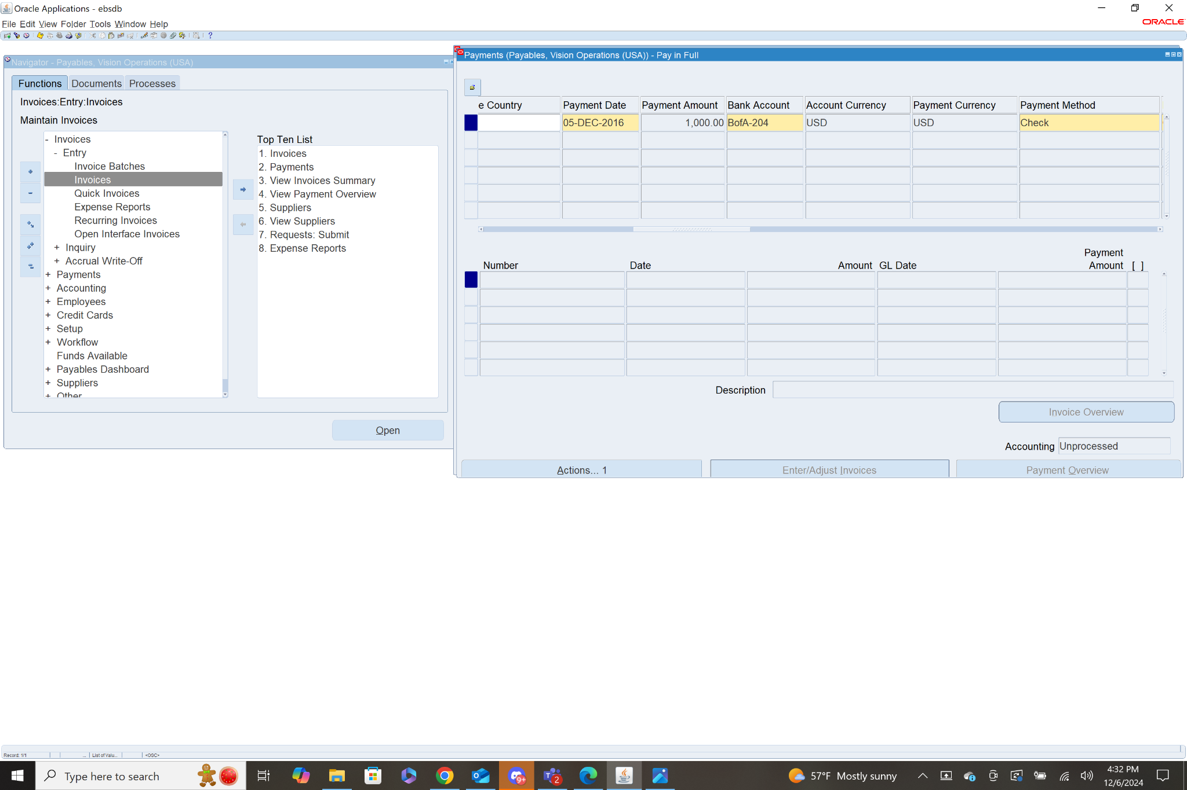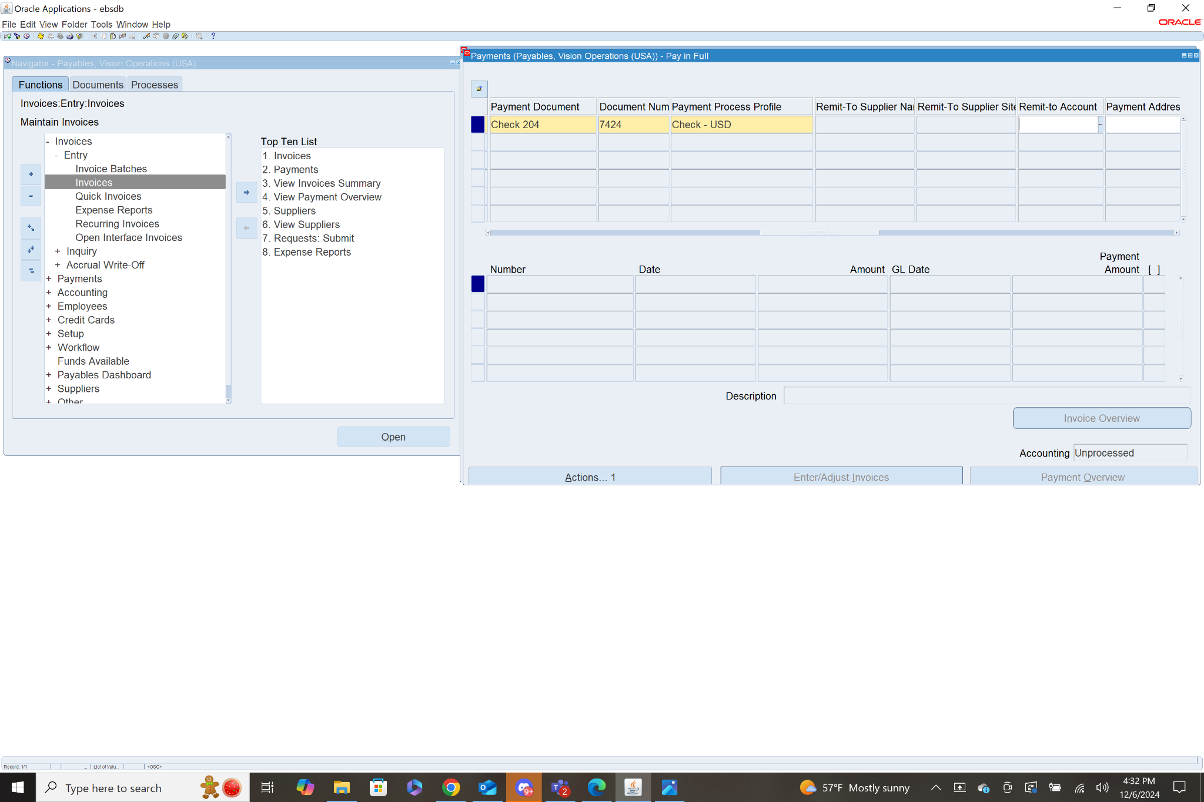

Then we need to create accounting, so click actions, select create accounting, final post, and click ok

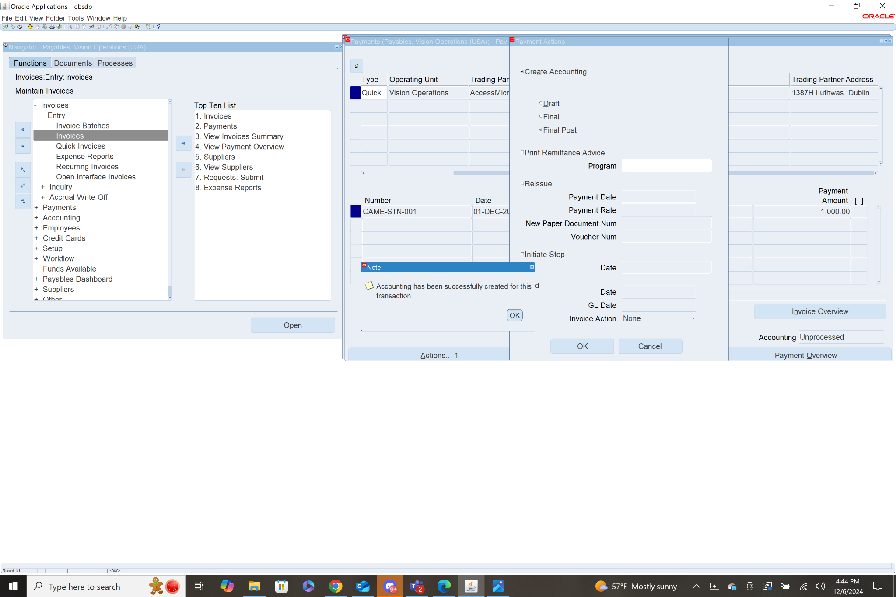

You can then print remittance advice. Remittance advice is used by the supplier to view details about the payment, including which invoices were paid, and payment amounts. To do this click actions again, select print remittance advice and choose a program, I chose federal remittance advice. Then click OK.

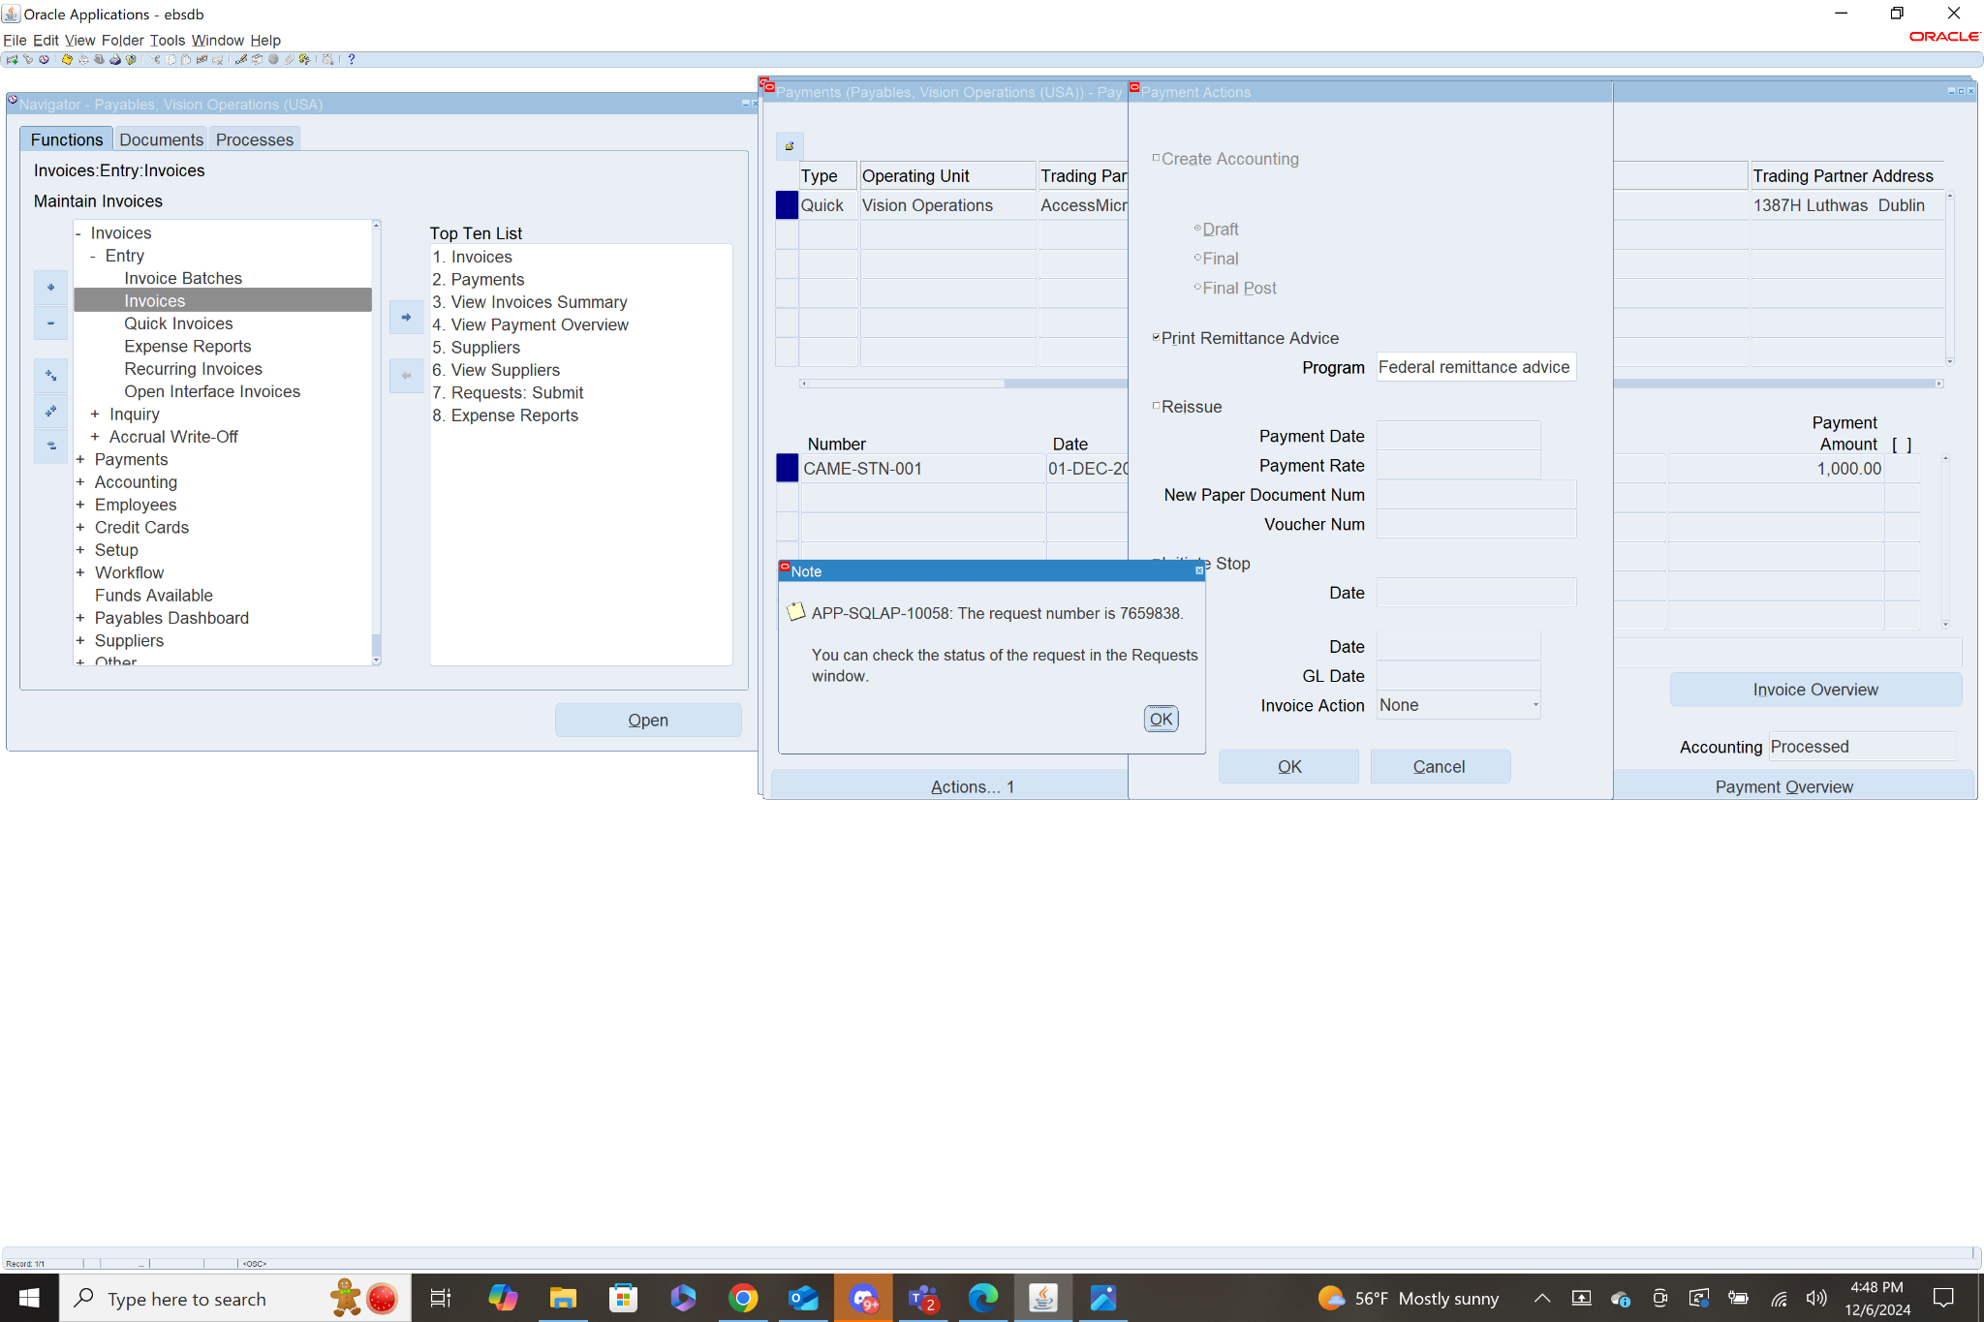

1. **Review Payment Status:**

* Check the payment status in the **Payments** window.
* Verify that the payment has been successfully processed and issued.

To check the payment status we will need to query the invoice again through the invoice workbench. **Payables>Invoices>Entry>Invoices.** Press FN+F11, fill in Invoice Num with “CAME-STN%” then press ctrl+FN+F11 to query the invoice.

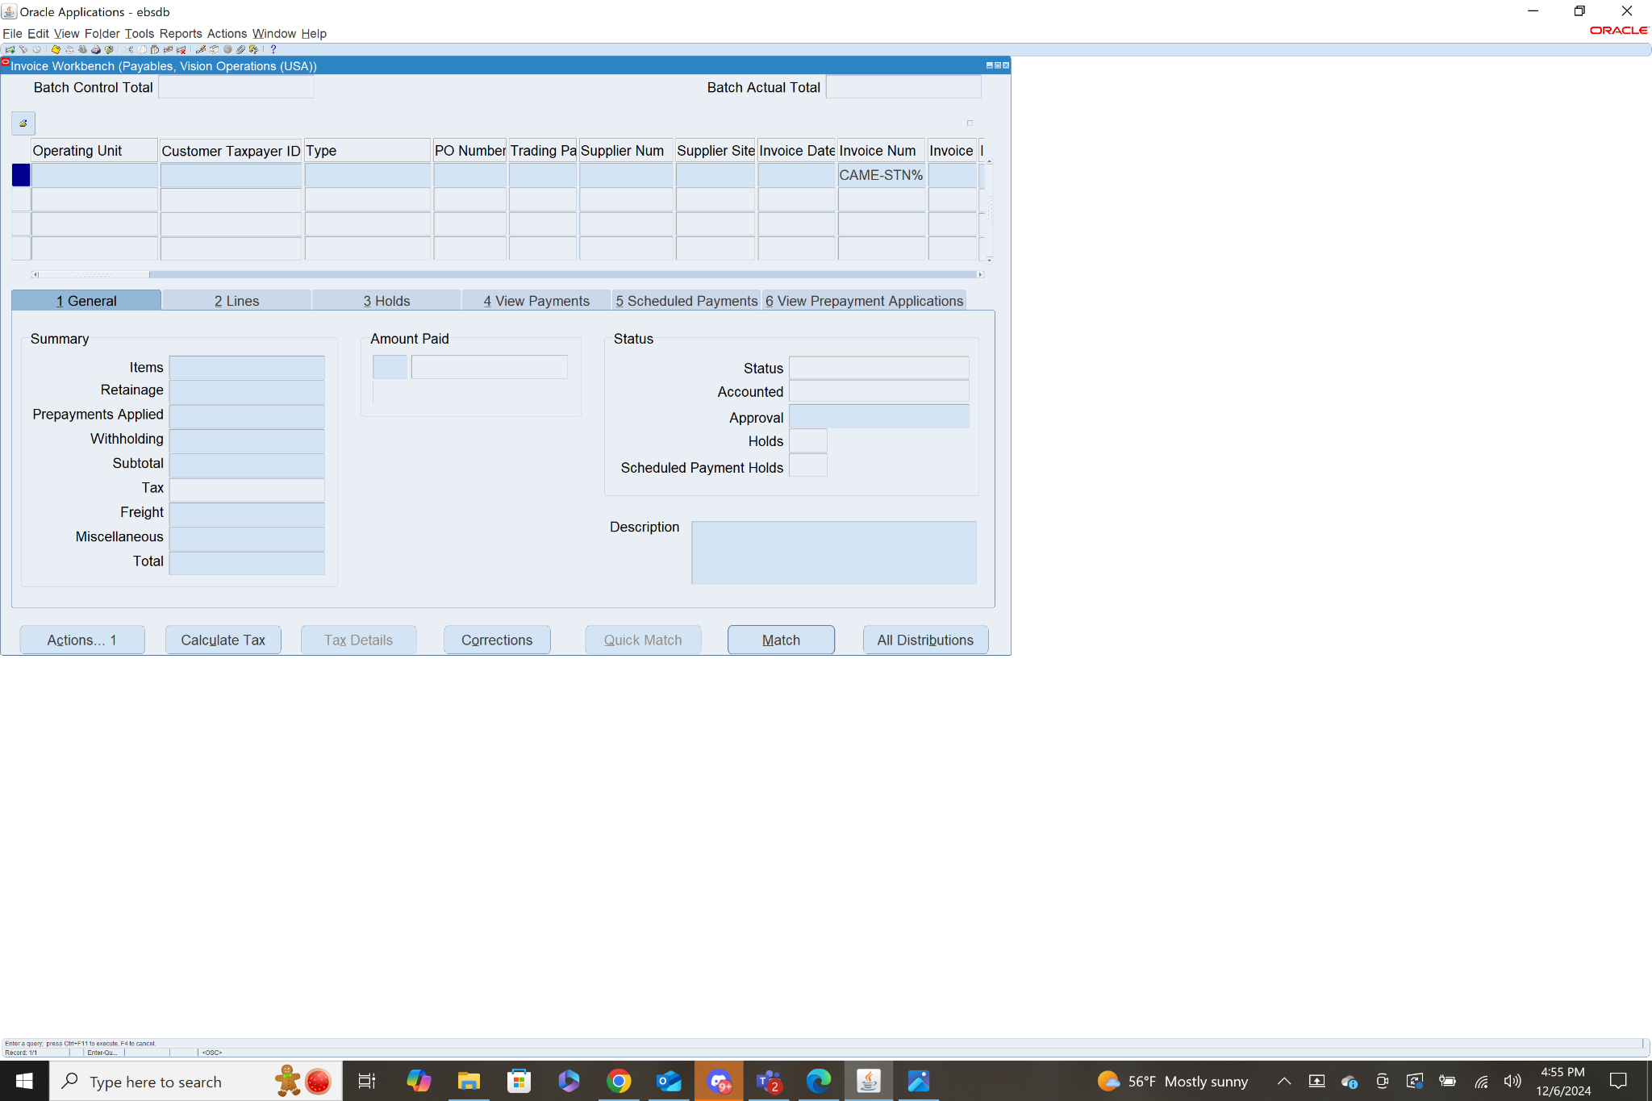

With the invoice selected in the general tab under the amount paid it should show the full invoice amount, $1000. This shows that the invoice has been paid.

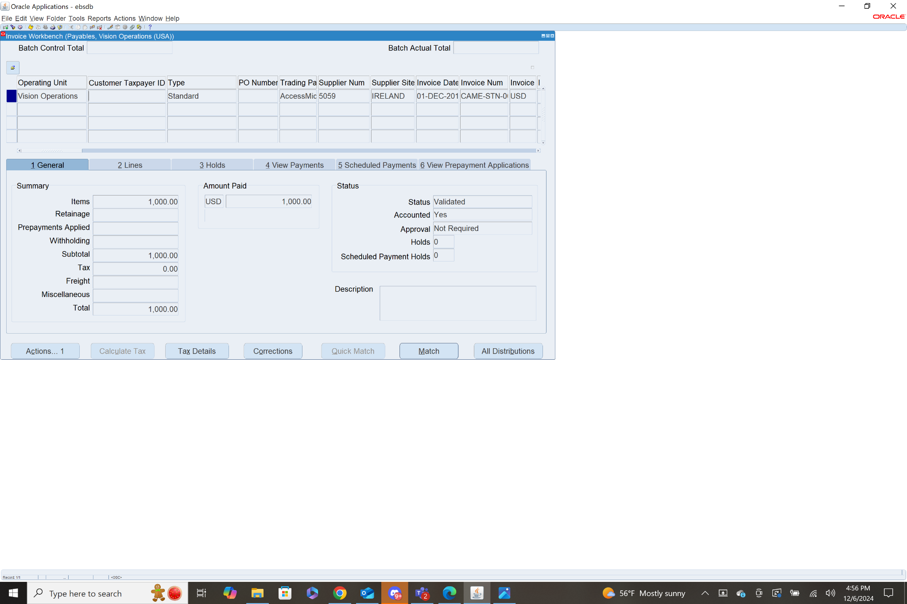

You can also view the payment in the view payments tab, and if you click payment overview, it will show all of the details concerning the payment.

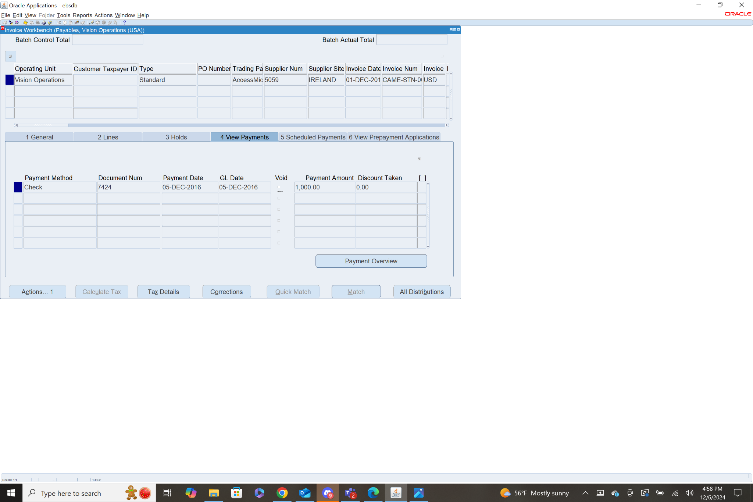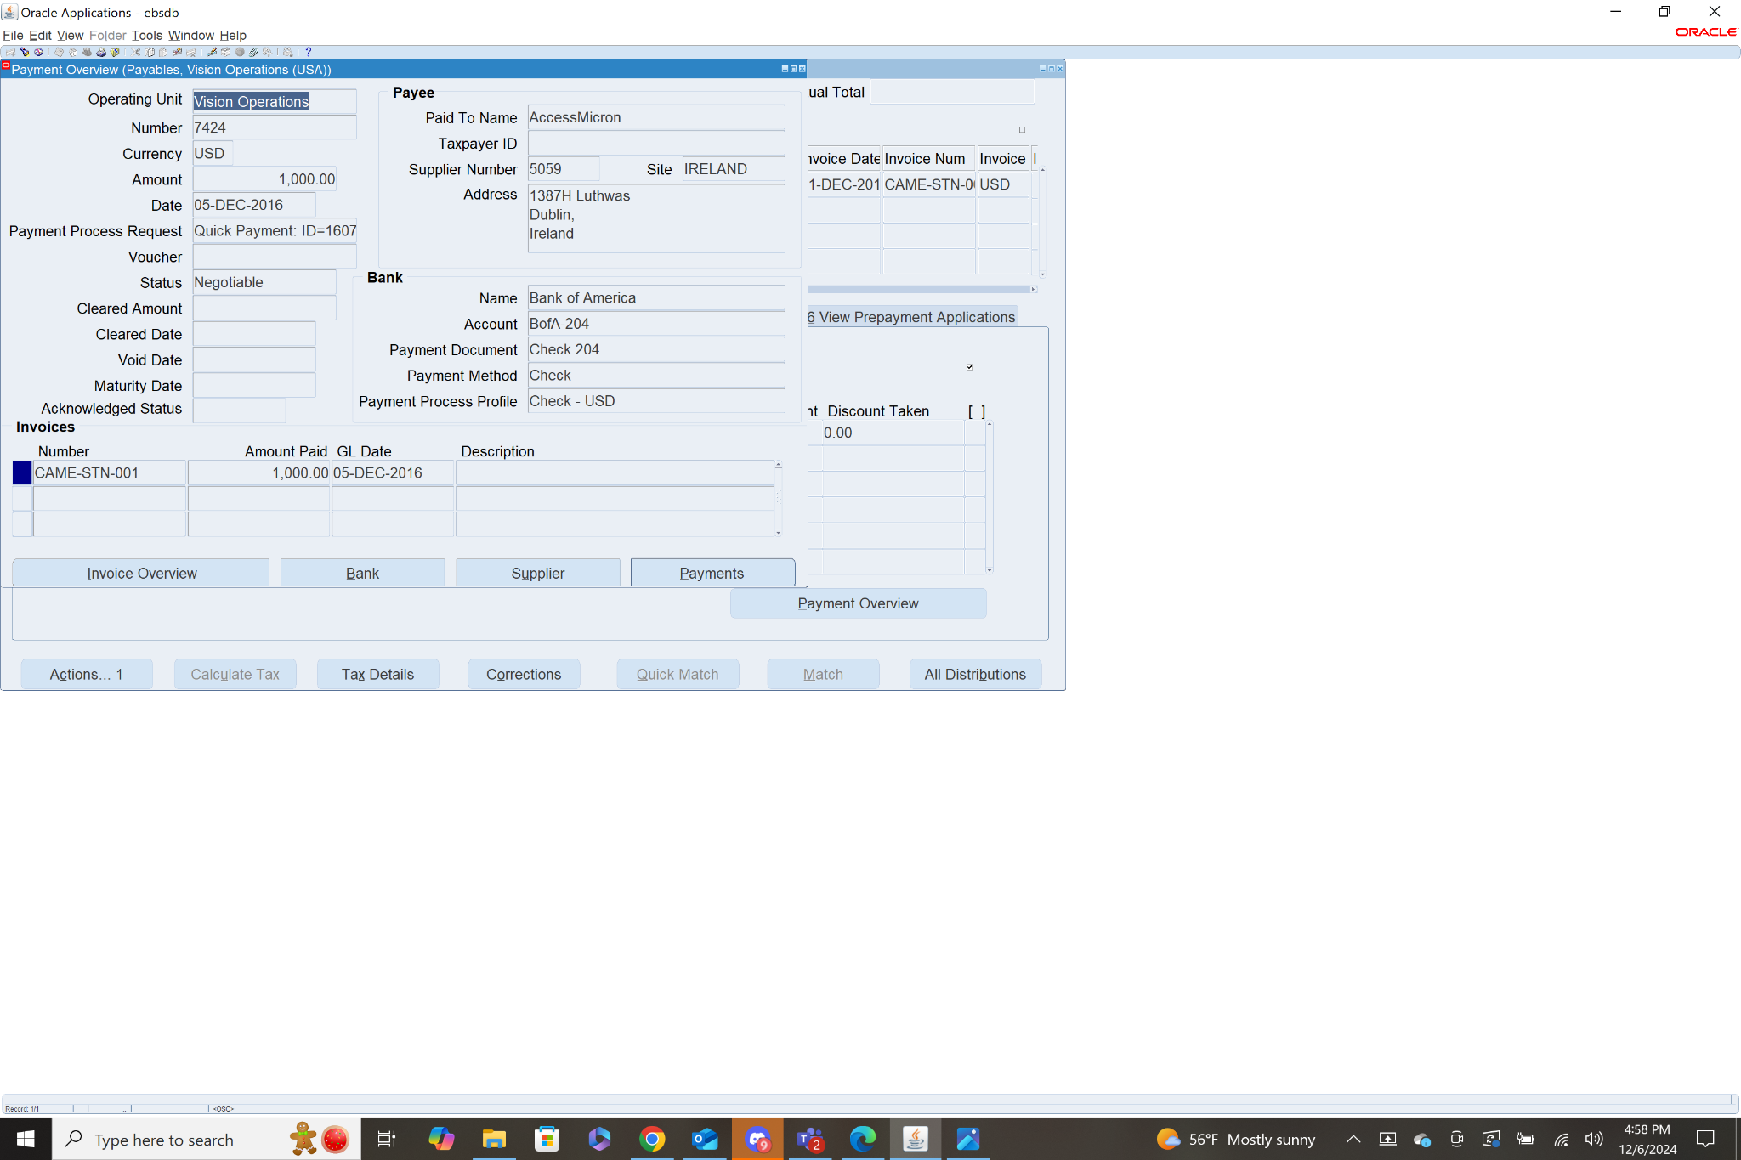

1. **Review the Accounting Entries:**

* Review the accounting entries for the invoice and payment.
* Ensure that the correct debits and credits are applied to the appropriate accounts (e.g., Expense and Bank accounts).

To view the accounting entries you must navigate to the subledger journal entries page. **Navigation: Payables>Accounting>Subledger Accounting>Journal Entries.**

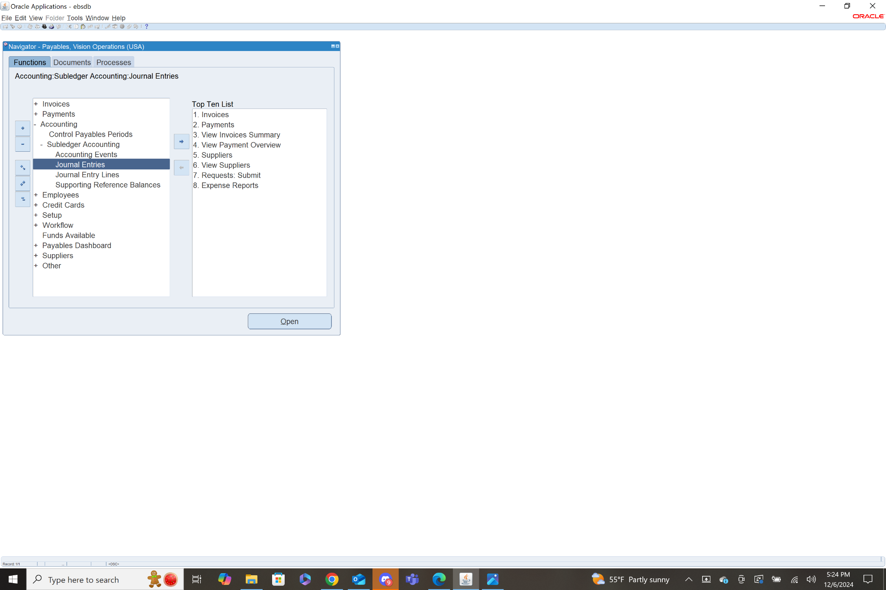

This will bring you to an html page where you can search for journal entries by GL Date. I chose two dates that would return both the invoice and payment.

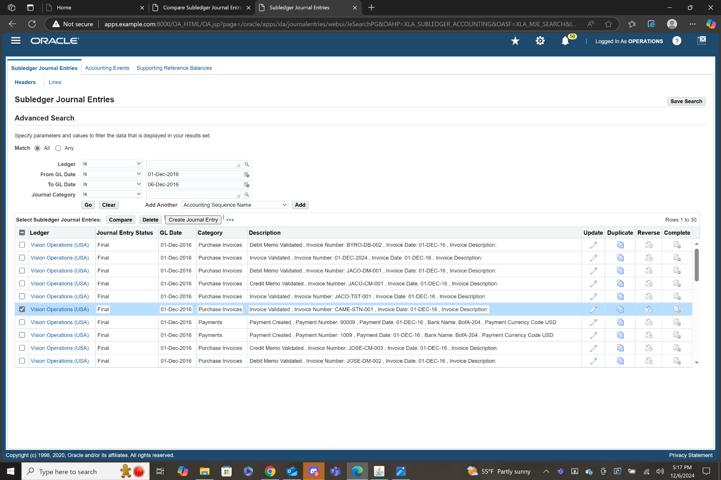

I then selected both the invoice and the payment. I was able to identify the invoice by the invoice number CAME-STN-001, and the invoice by the Payment number 7424 which matches the document number for the payment I created. I then clicked compare to view both accounting entries.

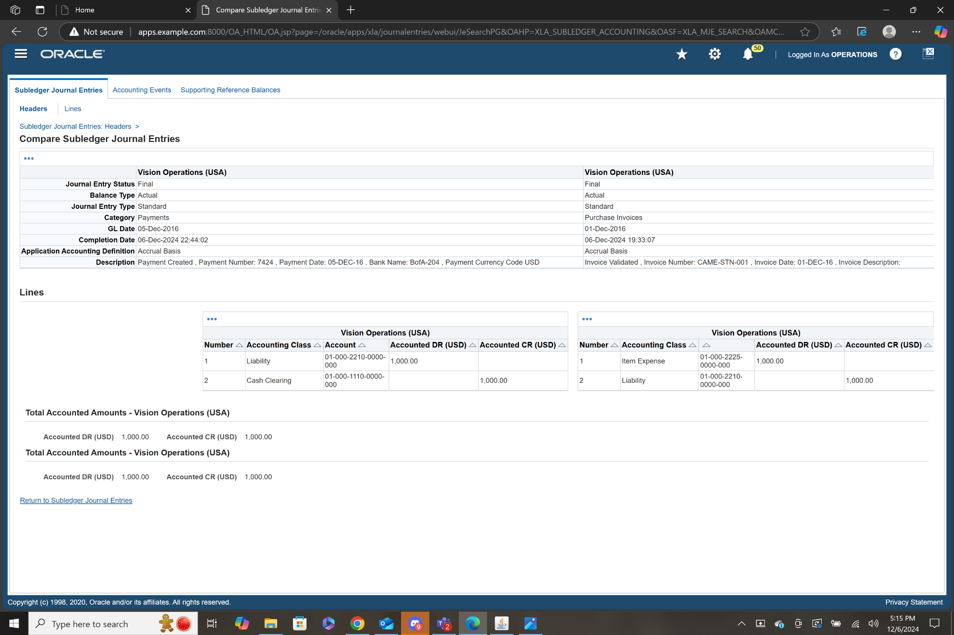

For the payment, Liability was debited and cash clearing was credited, both for the correct amount. For the invoice, Item Expense was Debited and Liability was credited, both for the correct amount.

1. **In Invoice Workbench how many types of Invoices are there?**

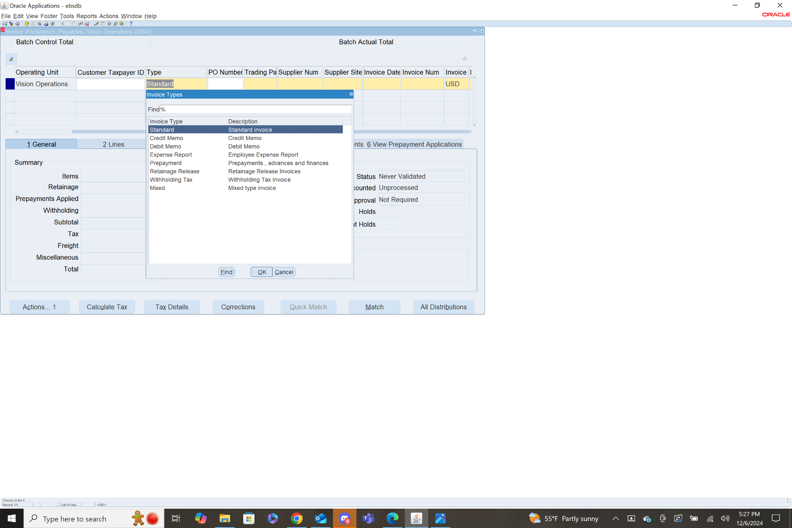

There are 8 different types of Invoices.

Standard- Used to record regular invoices from suppliers for goods and services received.

Credit Memo- Used to reduce the amount owed to a supplier.

Debit Memo- Used to increase the amount owed to a supplier.

Expense Report- Used to represent employee expense claims submitted for reimbursement.

Prepayment- Used to represent advance payments to a supplier.

Retainage Release- Used in industries like construction to release amounts withheld as retainage.

Withholding Tax- Used to calculate and record withholding tax amounts deducted from supplier payments.

Mixed- Used for both positive and negative amounts on a single invoice.

1. **Troubleshoot a Payables Issue: Hold**   
   Invoice line level variances [Hold] Release hole with Invoice Re-Validation

Invoice holds can happen for several reasons. Earlier when we created a debit memo and tried to validate the first time, we had a hold due to the invoice amount not including the tax amount.



This meant that the invoice was ineligible for validation because the amounts were not matching, and was given a status of Needs Revalidation. To fix this problem we simply had to go to the header line with the invoice amount, and correct it to include the tax amount. Once this is corrected, we can validate again, and as long as that was the only issue the invoice will be given a status of validated.



1. **In the PAYMENT Work Bench query the payment Document # (the Payment which you have done for Standard Invoice.**

First navigate to the payments workbench. **Navigation: Payables>Payments>Entry>Payments.**  Then press fn+f11 to allow you to query a specific field. Find Document Number and fill in the number, mine was 7424. Press ctrl+fn+f11 to run the query.

It returns the payment I made for the invoice earlier.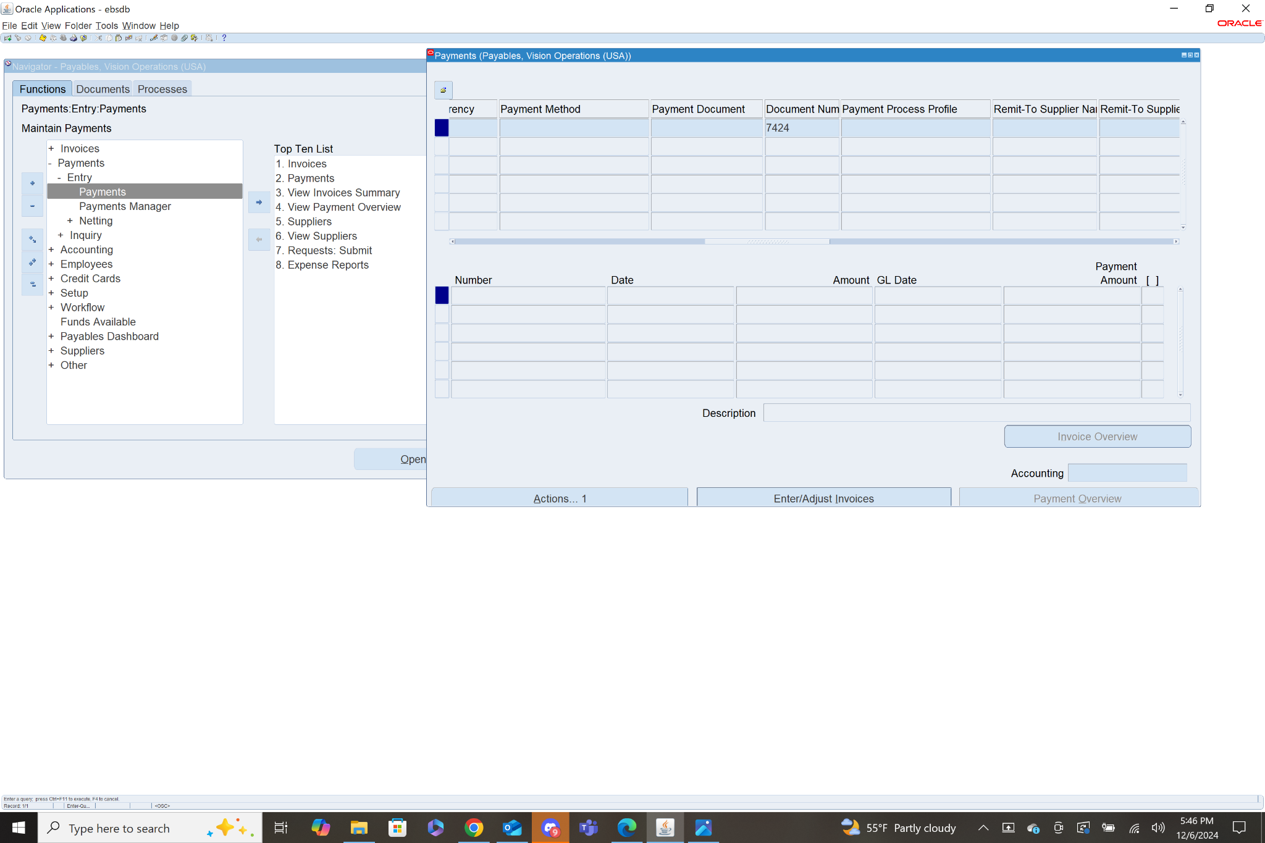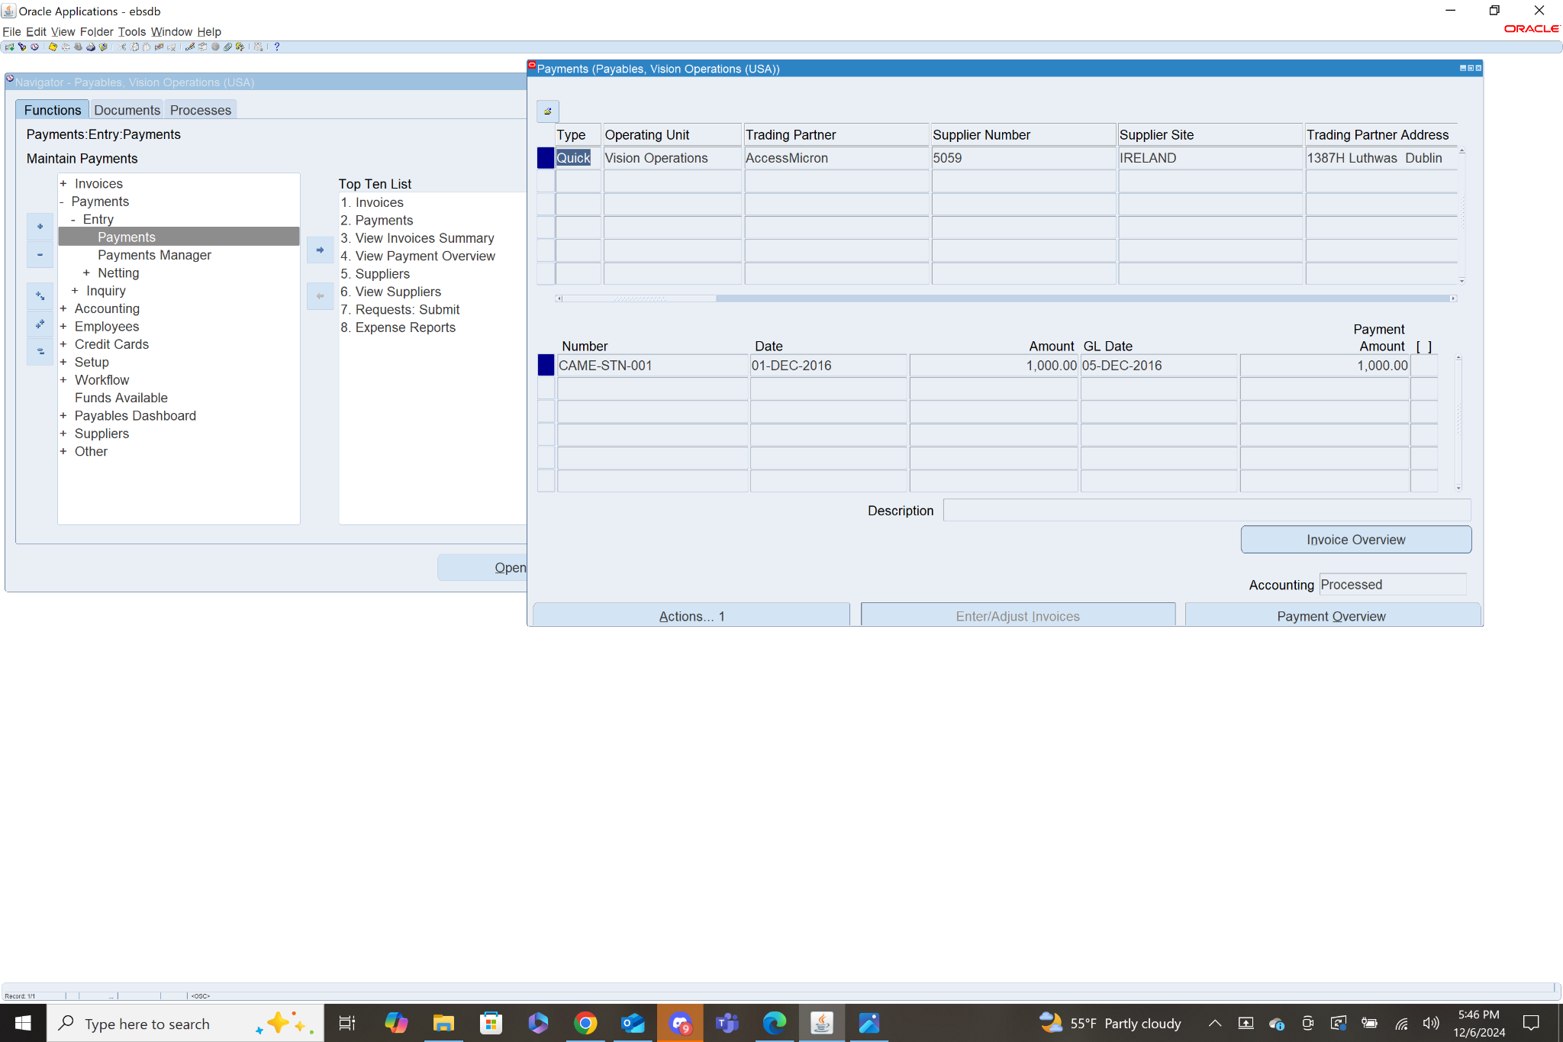

1. **Review the Payment accounting details.**

To review the payment accounting details navigate to the Subledger Journal Entries page.

**Navigation: Payables>Accounting>Subledger Accounting>Journal Entries**

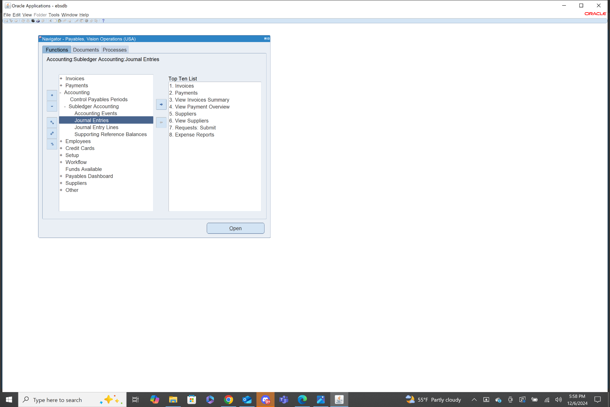

This brings you the Subledger Journal Entries html page. I searched by gl date of 05-Dec-2016, because that is the gl date of the payment I made.

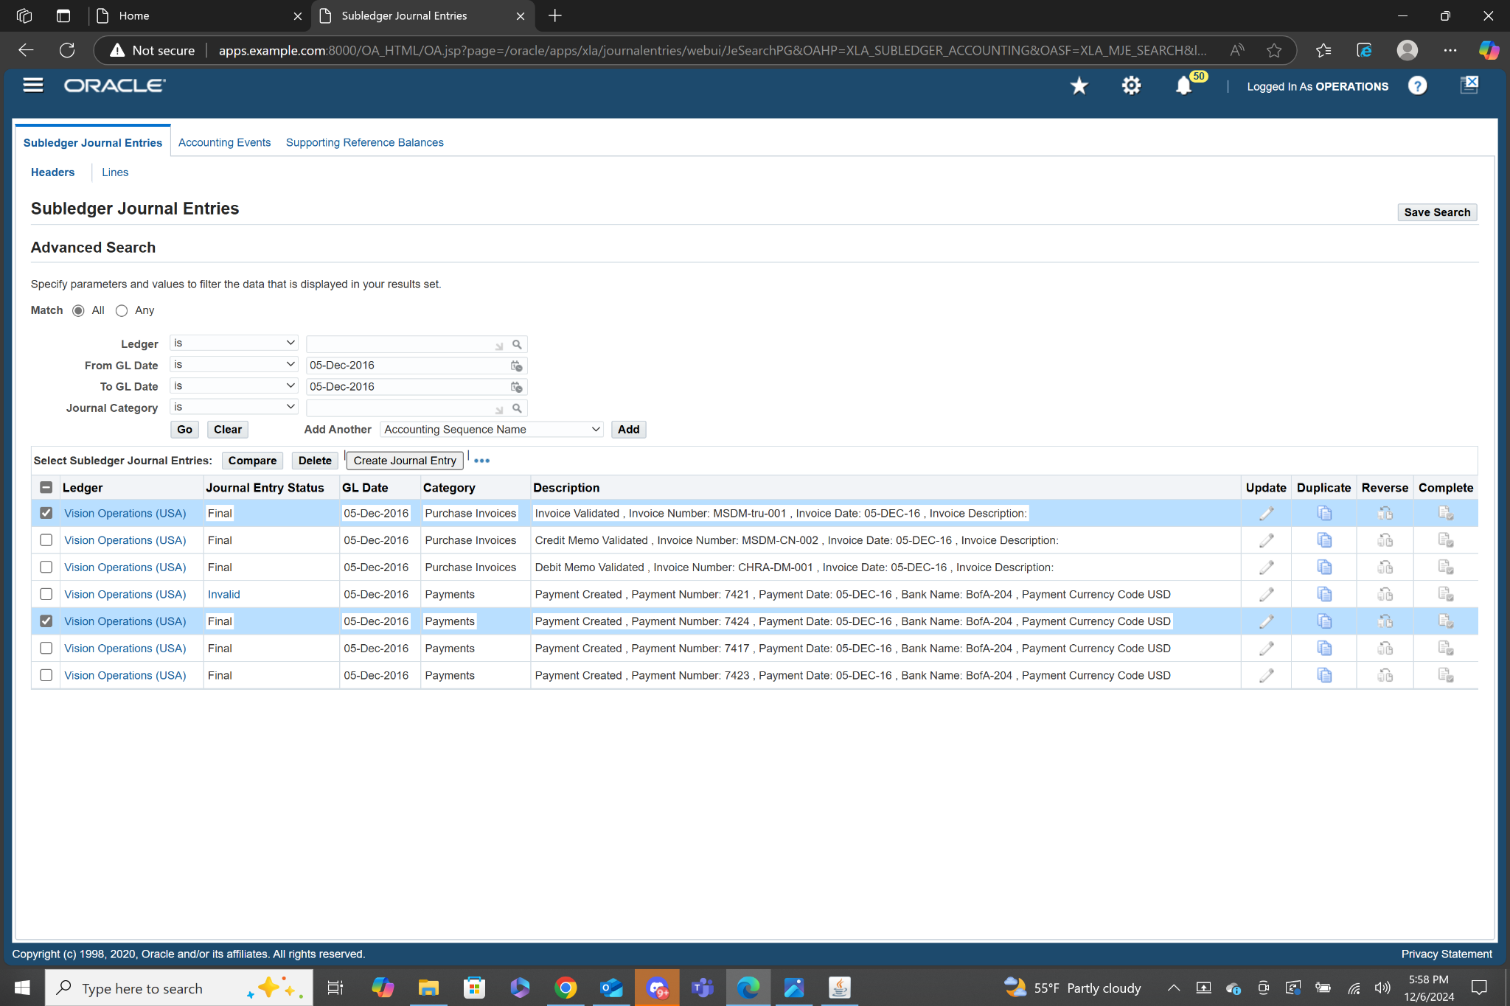

I then clicked on the entry with the payment number of 7424, which matches the document number of the payment I created.

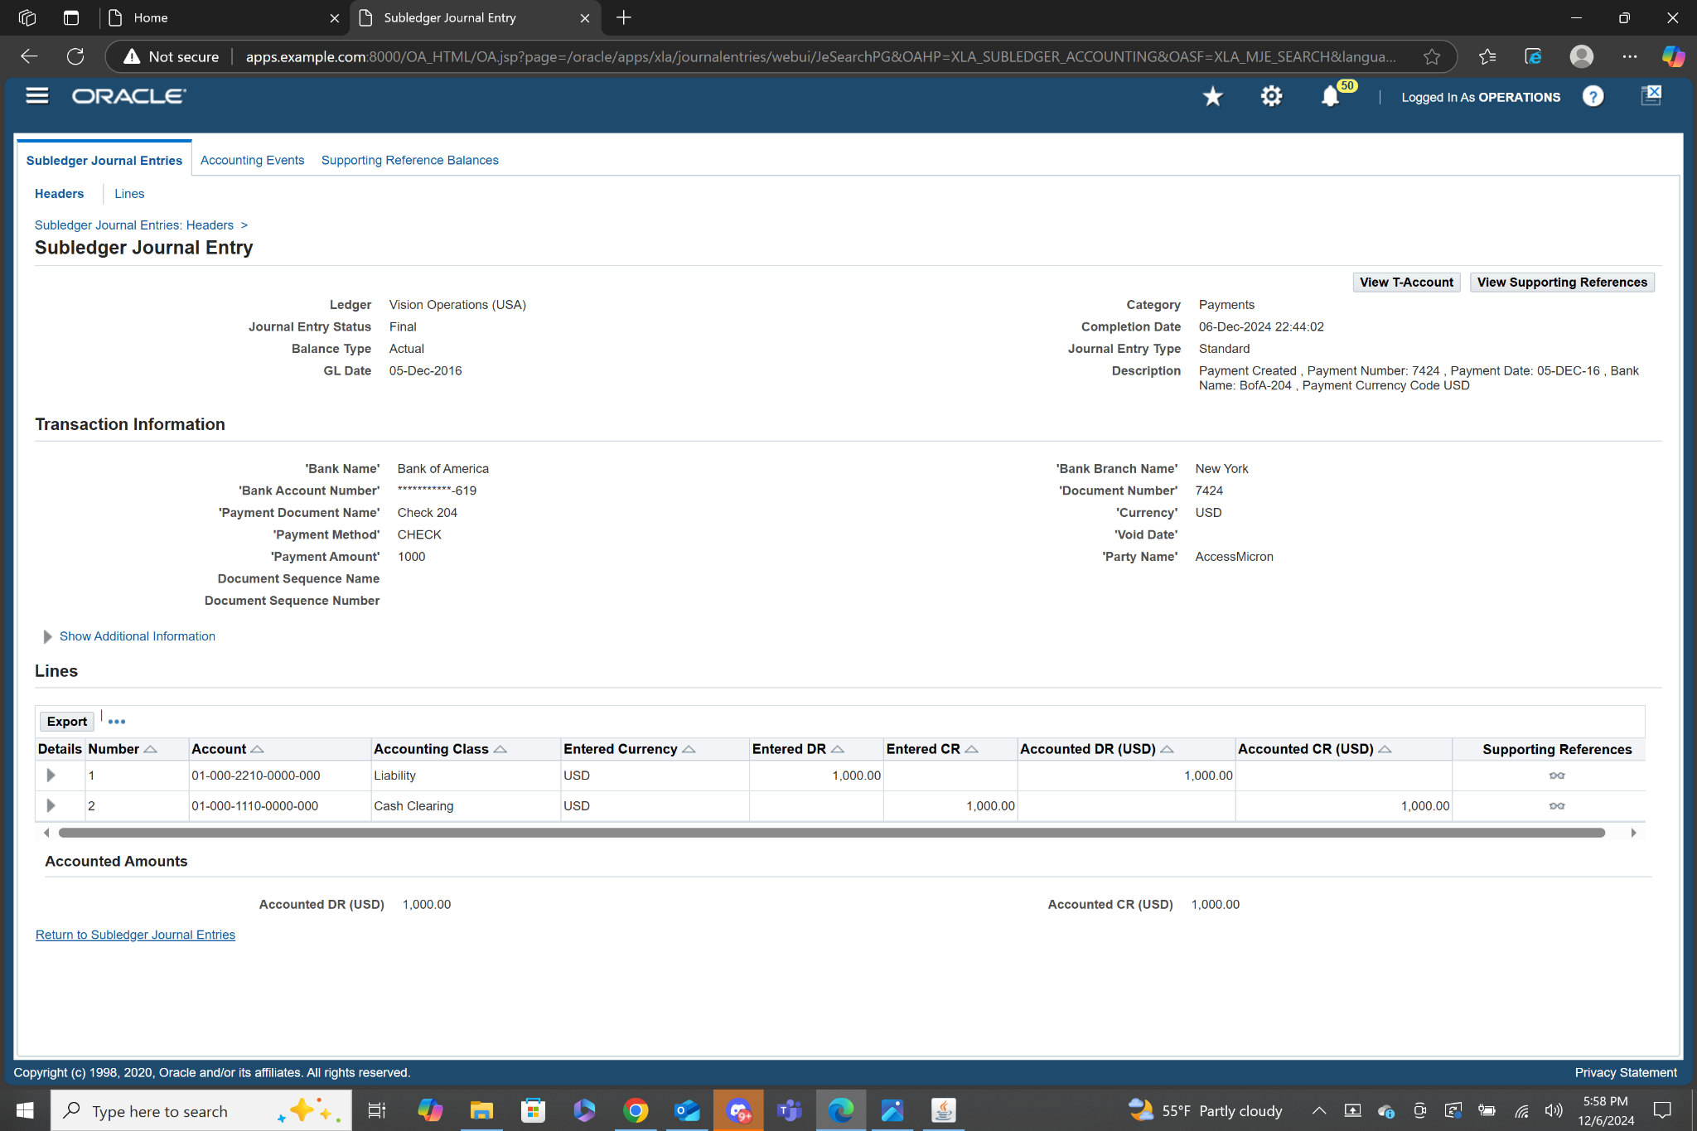

On this page we can view the accounting details as well as various information about the payment. We can see the liability account was accounted and entered as a debit of $1000. We can see the cash clearing account was accounted and entered as a credit of $1000.

**Cash Management:**

1. **Review the Bank account Details (Disbursement Bank) which you use for Payment.**

To review Bank account details navigate to manage bank accounts html page.

**Navigation: Cash Management, Vision Operations (USA)>Setup>Banks>Bank Accounts**

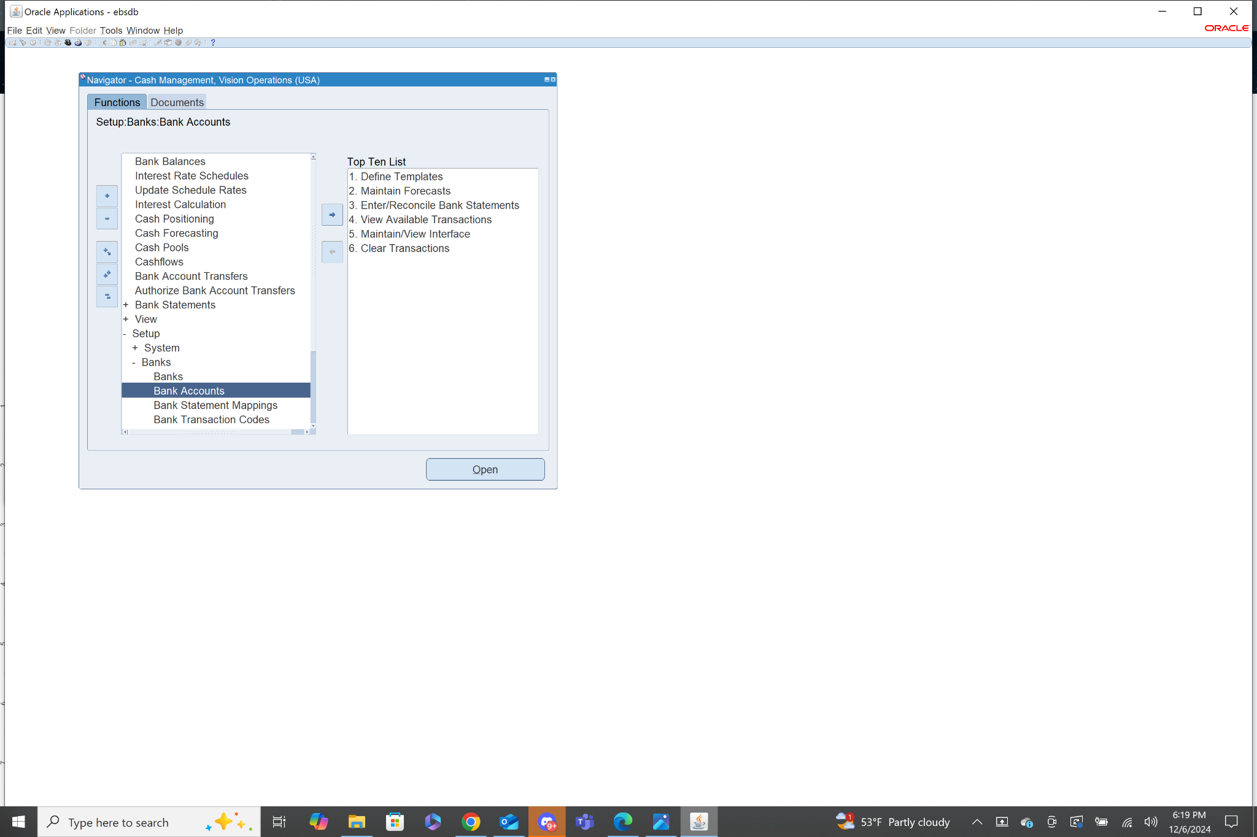

This will bring you to an html page where you can search for a specific bank. The bank account I used was from Bank of America with the Branch Name New York. I then searched for banks matching that criteria.I then cross checked the last 3 digits of the bank account number with the Bank I used for my payment.

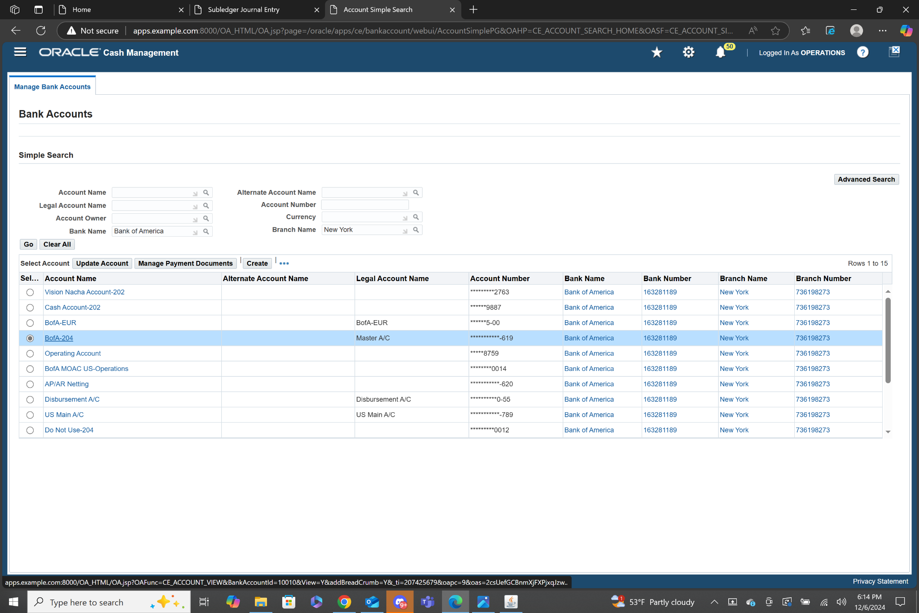

After clicking on the bank that matched up with the account number it brings me to a page with more detailed information on the bank account. On this page you can view the code combinations for various accounts related to this specific bank account, including cash, cash clearing, bank charges, bank errors, and foreign exchange charges. The cash clearing account was the one used in the payment transaction that I created. You can also see what is eligible to use this account, currently selected are payables, receivables, and treasury. I was in payables when I made the payment.

